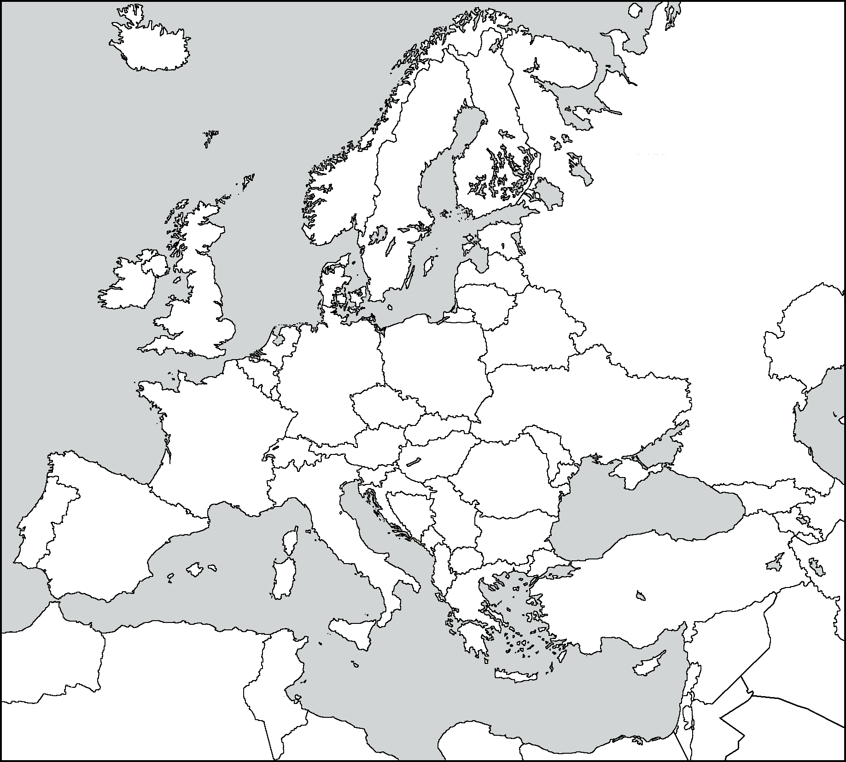
Name: ______________

Direction: Use page 969 and online sources to help you label: NATO countries, Soviet Union, Poland, West Germany, East Germany Czechoslovakia, Hungary, Romania, Bulgaria. Then shade in the map appropriately.

Europe during the Cold War
Years: __________

- NATO
- Western Occupation
- Soviet Union
- Soviet Occupation/ Satellite
- Neutral countries
- Neutral communist countries

Czechoslovakia

Read pages 966-974, The Cold War Unfolds, in your textbook and fill out the graphic organizer
Europe
- Established of NATO (West) and Warsaw Pact (East)

Soviet Union
- Established/lead the Warsaw Pact – alliances between Eastern European countries and USSR

United States
- Established/lead the NATO (North Atlantic Treaty Organization) – alliance between Western European countries and US
Consequences of the Cold War

