M.K. Gandhi
Creative Rebel

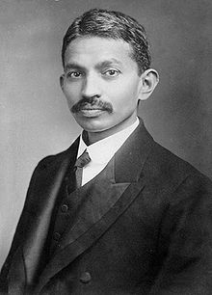
Who Was Gandhi?
Mohandas Gandhi is considered the father of the Indian independence movement. Gandhi spent 20 years in South Africa working to fight discrimination. It was there that he created his concept of satyagraha, a non-violent way of protesting against injustices. While in India, Gandhi's obvious virtue, simplistic lifestyle, and minimal dress endeared him to the people. He spent years working diligently to both remove British rule from India as well as to better the lives of India's poorest classes. Many civil rights leaders, including Martin Luther King Jr., used Gandhi's concept of non-violent protest as a model for their own struggles.
Dates: October 2, 1869 - January 30, 1948
Also Known As: Mohandas Karamchand Gandhi, Mahatma ("Great Soul"), Father of the Nation, Bapu ("Father"), Gandhiji

Gandhi's Childhood
Mohandas Gandhi was the last child of his father (Karamchand Gandhi) and his father's fourth wife (Putlibai). During his youth, Mohandas Gandhi was shy, soft-spoken, and only a mediocre student at school. Although generally an obedient child, at one point Gandhi experimented with eating meat, smoking, and a small amount of stealing -- all of which he later regretted. At age 13, Gandhi married Kasturba (also spelled Kasturbai) in an arranged marriage. Kasturba bore Gandhi four sons and supported Gandhi's endeavors until her death in 1944.

Off to London
In September 1888, at age 18, Gandhi left India, without his wife and newborn son, in order to study to become a barrister (lawyer) in London. Attempting to fit into English society, Gandhi spent his first three months in London attempting to make himself into an English gentleman by buying new suits, fine-tuning his English accent, learning French, and taking violin and dance lessons. After three months of these expensive endeavors, Gandhi decided they were a waste of time and money. He then cancelled all of these classes and spent the remainder of his three-year stay in London being a serious student and living a very simple lifestyle.
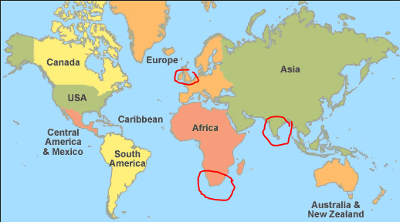
In addition to learning to live a very simple and frugal lifestyle, Gandhi discovered his life-long passion for vegetarianism while in England. Although most of the other Indian students ate meat while they were in England, Gandhi was determined not to do so, in part because he had vowed to his mother that he would stay a vegetarian. In his search for vegetarian restaurants, Gandhi found and joined the London Vegetarian Society. The Society consisted of an intellectual crowd who introduced Gandhi to different authors, such as Henry David Thoreau and Leo Tolstoy. It was also through members of the Society that Gandhi began to really read the Bhagavad Gita, an epic poem which is considered a sacred text to Hindus. The new ideas and concepts that he learned from these books set the foundation for his later beliefs.
Gandhi successfully passed the bar on June 10, 1891 and sailed back to India two days later. For the next two years, Gandhi attempted to practice law in India. Unfortunately, Gandhi found that he lacked both knowledge of Indian law and self-confidence at trial. When he was offered a year-long position to take a case in South Africa, he was thankful for the opportunity.

Gandhi Arrives in South Africa
At age 23, Gandhi once again left his family behind and set off for South Africa, arriving in British-governed Natal in May 1893. South Africa at that time (and today) has a large Indian population. The British used South Africans as laborers and merchants. The British practiced a policy of divide and control in their colonies, encouraging the movement of people from one colony to another. They found Indians easier to control than native Africans because they were so far from their home. Gandhi was to be one of the only Indian lawyers in South Africa.

It was in South Africa that Gandhi transformed from a very quiet and shy man to a resilient and potent leader against discrimination. The beginning of this transformation occurred during a business trip taken shortly after his arrival in South Africa.
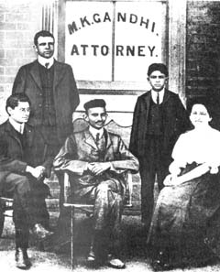
Gandhi had only been in South Africa for about a week when he was asked to take a long train trip. It was to be a several day trip. When Gandhi boarded the first train of his journey at the Pietermartizburg station, railroad officials told Gandhi that he needed to transfer to the third-class passenger car. When Gandhi, who was holding first-class passenger tickets, refused to move, a policeman came and threw him off the train.
That was not the last of the injustices Gandhi suffered on this trip. As Gandhi talked to other Indians in South Africa (derogatorily called "coolies"), he found that his experiences were most definitely not isolated incidents but rather, these types of situations were common. During that first night of his trip, sitting in the cold of the railroad station after being thrown off the train, Gandhi contemplated whether he should go back home to India or to fight the discrimination. After much thought, Gandhi decided that he could not let these injustices continue and that he was going to fight to change these discriminatory practices.

Gandhi, the Reformer
Gandhi spent the next twenty years working to better Indians' rights in South Africa. During the first three years, Gandhi learned more about Indian grievances, studied the law, wrote letters to officials, and organized petitions. On May 22, 1894, Gandhi established the Natal Indian Congress (NIC). Although the NIC began as an organization for wealthy Indians, Gandhi worked diligently to expand its membership to all classes and castes. Gandhi became well-known for his activism and his acts were even covered by newspapers in England and India. In a few short years, Gandhi had become a leader of the Indian community in South Africa.
In 1896, after living three years in South Africa, Gandhi sailed to India with the intention of bringing his wife and two sons back with him. While in India, there was a bubonic plague outbreak. Since it was then believed that poor sanitation was the cause of the spread of the plague, Gandhi offered to help inspect latrines and offer suggestions for better sanitation. Although others were willing to inspect the latrines of the wealthy, Gandhi personally inspected the latrines of the untouchables as well as the rich.
On November 30, 1896, Gandhi and his family headed for South Africa. Gandhi did not realize that while he had been away from South Africa, his pamphlet of Indian grievances, known as the Green Pamphlet, had been exaggerated and distorted. When Gandhi's ship reached the Durban harbor, it was detained for 23 days for quarantine. The real reason for the delay was that there was a large, angry mob of whites at the dock who believed that Gandhi was returning with two shiploads of Indian passengers to overrun South Africa. When allowed to disembark, Gandhi successfully sent his family off to safety, but he himself was assaulted with bricks, rotten eggs, and fists. Police arrived in time to save Gandhi from the mob and then escort him to safety. Once Gandhi had refuted the claims against him and refused to prosecute those who had assailed him, the violence against him stopped. However, the entire incident strengthened Gandhi's prestige in South Africa.
When the Boer War in South Africa began in 1899, Gandhi organized the Indian Ambulance Corp in which 1,100 Indians helped injured British soldiers. The goodwill created by this support of South African Indians to the British lasted just long enough for Gandhi to return to India for a year, beginning at the end of 1901. After traveling through India and successfully drawing public attention to some of the inequalities suffered by the lower classes of Indians, Gandhi returned to South Africa to continue his work there.

A Simplified Life
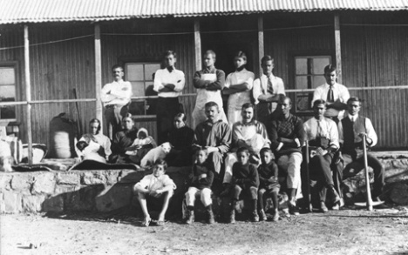
Influenced by the Gita, Gandhi wanted to purify his life by following the concepts of aparigraha (non-possession) and samabhava (equability). Then, when a friend gave him the book, Unto This Last by the European writer John Ruskin, Gandhi became excited about the Ruskin’s ideal of equality. The book inspired Gandhi to establish a communal living community called Phoenix Settlement just outside of Durban in June 1904. The Settlement was an experiment in communal living, a way to eliminate one's needless possessions and to live in a society with full equality. Gandhi moved his newspaper, the Indian Opinion, and its workers to the Phoenix Settlement as well as his own family. Besides a building for the press, each community member was allotted three acres of land on which to build a dwelling made of corrugated iron. In addition to farming, all members of the community were to be trained and expected to help with the newspaper, as well as performing tasks around the community.

Satyagraha
Gandhi came up with the concept of satyagraha in late 1906. In the very simplest sense, satyagraha is passive resistance. However, Gandhi believed the English phrase of "passive resistance" did not represent the true spirit of Indian resistance since passive resistance was often thought to be used by the weak and was a tactic that could potentially be conducted in anger.
Needing a new term for the Indian resistance, Gandhi chose the term "satyagraha," which literally means "truth force." Since Gandhi believed that exploitation was only possible if both the exploited and the exploiter accepted it, if one could see above the current situation and see the universal truth, then one had the power to make change. (Truth, in this manner, could mean "natural right," a right granted by nature and the universe that should not be impeded on by man.)
In practice, satyagraha was a focused and forceful nonviolent resistance to a particular injustice. A satyagrahi (a person using satyagraha) would resist the injustice by refusing to follow an unjust law. In doing so, he would not be angry, would put up freely with physical assaults to his person and the confiscation of his property, and would not use foul language to smear his opponent. A practitioner of satyagraha also would never take advantage of an opponent's problems. The goal was not for there to be a winner and loser of the battle, but rather, that all would eventually see and understand the "truth" and agree to rescind the unjust law.
The first time Gandhi officially used satyagraha was in South Africa beginning in 1907 when he organized opposition to the Asiatic Registration Law (known as the Black Act). In March 1907, the Black Act was passed, requiring all Indians - young and old, men and women - to get fingerprinted and to keep registration documents on them at all times. While using satyagraha, Indians refused to get fingerprinted and picketed the documentation offices. Mass protests were organized, miners went on strike, and masses of Indians illegally traveled from Natal to the Transvaal in opposition to the Black Act. Many of the protesters were beaten and arrested, including Gandhi. (This was the first of Gandhi's many jail sentences.) It took seven years of protest, but in June 1914, the Black Act was repealed. Gandhi had proved that nonviolent protest could be immensely successful.

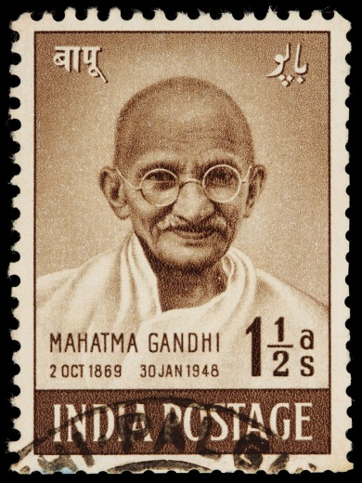
Back to India
Having spent twenty years in South Africa helping fight discrimination, Gandhi decided it was time to head back to India in July 1914. On his way home, Gandhi was scheduled to make a short stop in England. However, when World War I broke out during his journey, Gandhi decided to stay in England and form another ambulance corps of Indians to help the British. When the British air caused Gandhi to take ill, he sailed to India in January 1915.
Gandhi's struggles and triumphs in South Africa had been reported in the worldwide press, so by the time he reached home he was a national hero. Although he was eager to begin reforms in India, a friend advised him to wait a year and spend the time traveling around India to acquaint himself with the people and their tribulations.
Yet Gandhi soon found his fame getting in the way of accurately seeing the conditions that the poorer people lived in day to day. In an attempt to travel more anonymously, Gandhi began wearing a loincloth (dhoti) and sandals (the average dress of the masses) during this journey. If it was cold out, he would add a shawl. This became his wardrobe for the rest of his life.
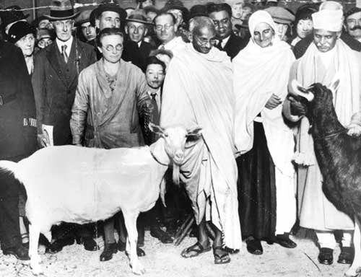
Also during this year of observation, Gandhi founded another communal settlement, this time in Ahmadabad and called the Sabarmati Ashram. Gandhi lived on the Ashram for the next sixteen years, along with his family and several members who had once been part of the Phoenix Settlement.

Mahatma
It was during his first year back in India that Gandhi was given the honorary title of Mahatma ("Great Soul"). Many credit Indian poet Rabindranath Tagore, winner of the 1913 Nobel Prize for Literature, for both awarding Gandhi of this name and of publicizing it. The title represented the feelings of the millions of Indian peasants who viewed Gandhi as a holy man. However, Gandhi never liked the title because it seemed to mean he was special while he viewed himself as ordinary.
After Gandhi's year of travel and observance was over, he was still stifled in his actions because of the World War. As part of satyagraha, Gandhi had vowed to never take advantage of an opponent's troubles. With the British fighting a huge war, Gandhi could not fight for Indian freedom from British rule. This did not mean that Gandhi sat idle.
Instead of fighting the British, Gandhi used his influence and satyagraha to change inequities between Indians. For example, Gandhi persuaded landlords (many of whom were British) to stop forcing poor farmers to pay increased rent and accept low prices for the cash crops that they were forced to grow. Gandhi was arrested for his protests on behalf of farmers. This arrest turned into a public relations nightmare for the British as it brought attention to the starvation conditions that resulted from British agricultural and trade policies.
Gandhi used his fame and determination to appeal to the landlords' morals and used fasting as a means to convince the British authorities to improve the lives of poor farmers. Gandhi's reputation and prestige had reached such a high level that people did not want to be responsible for his death (fasting made Gandhi physically weak and in ill-health, with the potential for death). The British were concerned that if Gandhi died, they would be unable to control the reaction. There were never more than about 20,000 British officials in India to control a population of over 300 million. The British relied on Indian Sepoys and workers to run India as a colony.

Turning Against the British
As the First World War reached its end, it was time for Gandhi to focus on the fight for Indian self-rule (swaraj). In 1919, the British gave Gandhi something specific to fight against - the Rowlatt Act. This Act gave the British in India nearly free-reign to root out "revolutionary" elements and to detain them indefinitely without trial. In response to this Act, Gandhi organized a mass general strike (almost all Indians refused to work), which began on March 30, 1919. Unfortunately, such a large scale protest quickly got out of hand and in many places it turned violent.
Even though Gandhi called off the general strike once he heard about the violence, over 300 Indians had died and over 1,100 were injured from British reprisal in the city of Amritsar. Although satyagraha had not been realized during this protest, the Amritsar Massacre heated Indian opinion against the British.
The violence that erupted from the general strike showed Gandhi that the Indian people did not yet fully believe in the power of satyagraha. Thus, Gandhi spent much of the 1920s advocating for satyagraha and struggling to learn how to control nationwide protests to keep them from becoming violent.
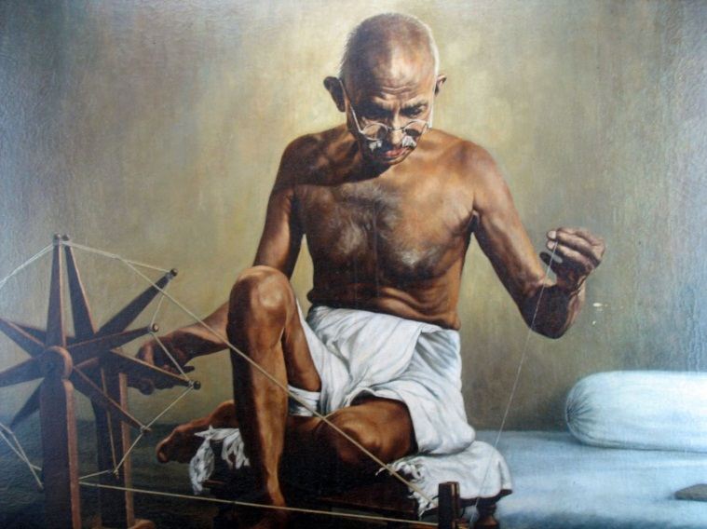
In March 1922, Gandhi was jailed for sedition and after a trial was sentenced to six years in prison. After two years, Gandhi was released due to ill-health following surgery to treat his appendicitis. Upon his release, Gandhi found his country embroiled in violent attacks between Muslims and Hindus. As penance for the violence, Gandhi began a 21-day fast, known as the Great Fast of 1924. Still ill from his recent surgery, many thought he would die on day twelve, but he rallied. The fast created a temporary peace.
Also during this decade, Gandhi began advocating self-reliance as a way to gain freedom from the British. For example, from the time that the British had established India as a colony, the Indians were supplying Britain with raw materials and then importing expensive, woven cloth from England. Thus, Gandhi advocated that Indians spin their own cloth to free themselves from this reliance on the British. Gandhi popularized this idea by traveling with his own spinning wheel, often spinning yarn even while giving a speech. In this way, the image of the spinning wheel (charkha) became a symbol for Indian independence.

The Amritsar Massacre and Salt March:
On April 13, 1919, British troops under Brigadier-General Reginald Dyer opened fire on an unarmed crowd in the courtyard of Jallianwala Bagh. Between 379 (the British count) and 1,499 (the Indian count) of the 5,000 men, women and children present died in the melee.
The Jallianwala Bagh or Amritsar Massacre turned the Indian independence movement into a national cause, and brought Gandhi to national attention. Gandhi's independence work culminated in the 1930 Salt March, when he led his followers to the sea to illegally make salt, a protest against British salt taxes.
Some independence protestors also turned to violence.

World War II and the "Quit India" Movement:
When World War II broke out in 1939, Britain turned to its colonies, including India, for soldiers. Gandhi was conflicted; he felt very concerned about the rise of fascism around the world, but he also had become a committed pacifist. No doubt, he remembered the lessons of the Boer War and World War I - loyalty to the colonial government during war did not result in better treatment afterwards.
In March of 1942, British cabinet minister Sir Stafford Cripps offered the Indians a form of autonomy within the British Empire in exchange for military support. The Cripps offer included a plan to separate the Hindu and Muslim sections of India, which Gandhi found unacceptable. The Indian independence movement rejected the plan.
That summer, Gandhi issued a call for Britain to "Quit India" immediately. The colonial government reacted by arresting all of the Congress leadership, including Gandhi and his wife Kasturba. As anti-colonial protests grew, the Raj government arrested and jailed hundreds of thousands of Indians.
Tragically, Kasturba died in February 1944 after 18 months in prison. Gandhi became gravely ill with malaria, so the British released him from prison. The political repercussions would have been explosive, if he had also died while imprisoned.

Indian Independence and Partition
In 1944, Britain pledged to grant independence to India once the war was over. Gandhi called for the Congress to reject the proposal once more, since it proposed a division of India among Hindu, Muslim, and Sikh states. The Hindu states would become one nation, while the Muslim and Sikh states would be another.
When sectarian violence rocked India's cities in 1946, leaving more than 5,000 dead, Congress members convinced Gandhi that the only options were partition or civil war. He reluctantly agreed, and then went on a hunger strike that single-handedly stopped the violence in Delhi and Calcutta.
On August 14, 1947, the Islamic Republic of Pakistan was founded. The Republic of India declared its independence the following day.

Gandhi's Assassination
On January 30, 1948, Mohandas Gandhi was shot dead by a young Hindu radical named Nathuram Godse. The assassin blamed Gandhi for weakening India by insisting on respecting the rights of Muslims and Sikhs, and urging peace between Pakistan and India.
Despite Gandhi's rejection of violence and revenge during his lifetime, Godse and an accomplice were both executed in 1949 for the murder

