How to create a MLA Work Cited Page
- Go to your NoodleTools account
- Open up your project
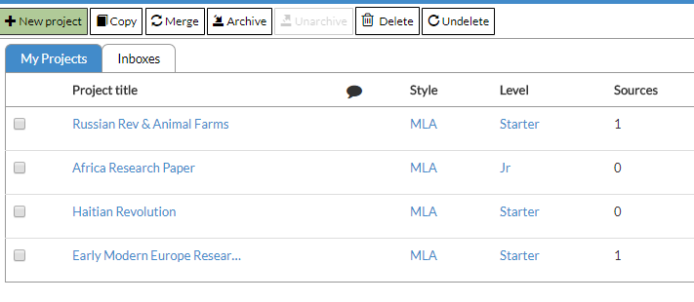
- Once your project dashboard opens up, click on “Source” at the top center
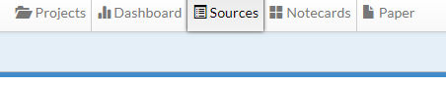

- Click on the drop down menu: Print/Export
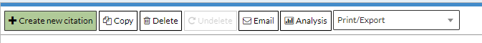

- Select Print/Export to Word or Google Docs and it will print out a Work Cited Page for you!
