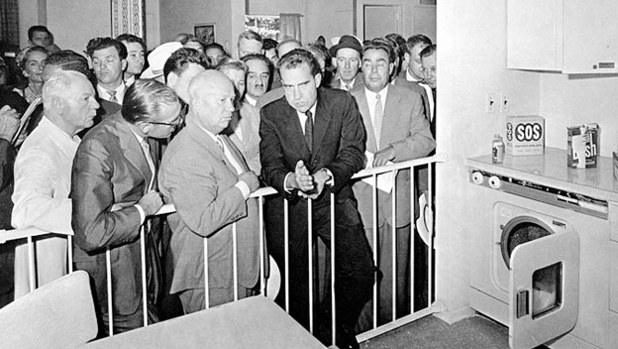
The Kitchen Debate
Vice President Richard Nixon and Soviet Premier Nikita Khrushchev. Moscow, Soviet Union 1959

In late 1958, the Soviet Union and the United States agreed to set up national exhibitions in each other’s nation as part of their new emphasis on cultural exchanges. The U.S. exhibition opened in Sokolniki Park in Moscow in July.
During the grand opening ceremony of the American National Exhibition in Moscow, Vice President Richard Nixon and Soviet leader Nikita Khrushchev engage in a heated debate about capitalism and communism in the middle of a model kitchen set up for the fair. The so-called “kitchen debate” became one of the most famous episodes of the Cold War.

[Both men enter kitchen in the American exhibit.]
Nixon: I want to show you this kitchen. It is like those of our houses in California.
[Nixon points to dishwasher.]
Khrushchev: We have such things.
Nixon: This is our newest model. This is the kind which is built in thousands of units for direct installations in the houses. In America, we like to make life easier for women…
Khrushchev: Your capitalistic attitude toward women does not occur under Communism.
Nixon: I think that this attitude towards women is universal. What we want to do, is make life more easy for our housewives…..
How are women being described?

What is the relationship between women and capitalism?

What might this mean for the general American/Western woman (at the time)?

Nixon: This house can be bought for $14,000, and most American [veterans from World War II] can buy a home in the bracket of $10,000 to $15,000 [by a general worker].

Khrushchev: We have … workers and peasants who can afford to spend $14,000 for a house. Your American houses are built to last only 20 years so builders could sell new houses at the end. We build firmly. We build for our children and grandchildren.

Nixon: American houses last for more than 20 years, but, even so, after twenty years, many Americans want a new house or a new kitchen. Their kitchen is obsolete by that time….The American system is designed to take advantage of new inventions and new techniques.

Khrushchev: This theory does not hold water. Some things never get out of date–houses, For instance, and furniture, furnishings–perhaps–but not houses. I have read much about America and American houses, and I do not think that this is exhibit and what you say is strictly accurate.
How do Soviets view consuming good, like homes?

How do American view consuming good, like homes?

How has this consumerist ideal escalated in America today? Specific example?

** consuming goods = buying new stuff

Khrushchev: In Russia, all you have to do to get a house is to be born in the Soviet Union. You are entitled to housing…In America, if you don’t have a dollar you have a right to choose between sleeping in a house or on the pavement. Yet you say we are the slave to Communism.
Nixon: …. This exhibit was not designed to astound but to interest. Diversity, the right to choose, the fact that we have 1,000 builders building 1,000 different houses is the most important thing. We don’t have one decision made at the top by one government official. This is the difference.
What argument is Khrushchev making in favor of Communism?

What is Nixon’s refutation in favor of capitalism and democracy?

Other Russian speaker: Tell us, please, what are your general impressions of the exhibit?
Khrushchev: It’s clear to me that the construction workers didn’t manage to finish their work and the exhibit still is not put in order…This is what America is capable of, and how long has she existed? 300 years? 150 years of independence and this is her level. We haven’t quite reached 42 years, and in another 7 years, we’ll be at the level of America, and after that we’ll go farther. As we pass you by, we’ll wave “hi” to you, and then if you want, we’ll stop and say, “please come along behind us.” …If you want to live under capitalism, go ahead, that’s your question, an internal matter, it doesn’t concern us. We can feel sorry for you, but really, you wouldn’t understand. We’ve already seen how you understand things.
Other U.S speaker: Mr. Vice President, from what you have seen of our exhibition, how do you think it’s going to impress the people of the Soviet Union?
Nixon: It’s a very effective exhibit, and it’s one that will cause a great deal of interest…. As far as Mr Khrushchev’s comments just now, they are in the tradition we learned to expect from him of speaking extemporaneously and frankly whenever he has an opportunity. I can only say that if this competition which you have described so effectively, in which you plan to outstrip us, particularly in the production of consumer goods…If this competition is to do the best for both of our peoples and for people everywhere, there must be a free exchange of ideas. There are some instances where you may be ahead of us–for example in the development of the thrust of your rockets for the investigation of outer space. There may be some instances, for example, color television, where we’re ahead of you. But in order for both of us benefit…
Khrushchev: [interrupting] No, in rockets we’ve passed you by, and in the technology…
Nixon: [continuing to talk] You see, you never concede anything.
Khrushchev: We always knew that Americans were smart people. Stupid people could not have risen to the economic level that they’ve reached. But as you know, “we don’t beat flies with our nostrils!” [we are not fools either] In 42 years we’ve made progress.
Nixon: You must not be afraid of ideas.
Khrushchev: We’re saying it is you who must not be afraid of ideas. We’re not afraid of anything….
What is Khrushchev trying to communicate to Nixon here?

What is Nixon trying to communicate?

Khrushchev: You’re a lawyer of Capitalism, I’m a lawyer for Communism. Let’s kiss.
How is the metaphor of “lawyers” significant to this discussion?

Nixon: All that I can say, from the way you talk and the way you dominate the conversation, you would have made a good lawyer yourself. What I mean is this: Here you can see the type of [video] tape which will transmit this very conversation immediately, and this indicates the possibilities of increasing communication. And this increase in communication, will teach us some things, and you some things, too. Because, after all, you don’t know everything.
Khrushchev: If I don’t know everything, then you know absolutely nothing about Communism, except for fear! But now the dispute will be on an unequal basis. The apparatus is yours, and you speak English, while I speak Russian. Your words are taped and will be shown and heard. What I say to you about science won’t be translated, and so your people won’t hear it. These aren’t equal conditions.
Nixon: There isn’t a day that goes by in the United States when we can’t read everything that you say in the Soviet Union…And, I can assure you, never make a statement here that you don’t think we read in the United States.
Khrushchev: If that’s the way it is, I’m holding you to it. Give me your word…I want you, the Vice President, to give me your word that my speech will also be taped in English. Will it be?
Nixon: Certainly it will be. And by the same token, everything that I say will be recorded and translated and will be carried all over the Soviet Union. That’s a fair bargain.
[Both men shake hands and walk off stage, still talking.]
What is the mood of these concluding statements? Do they end of very good terms?

How is this representative of Cold War attitudes?

