Supreme Court Case:
United States v. Wong Kim Ark (1898)

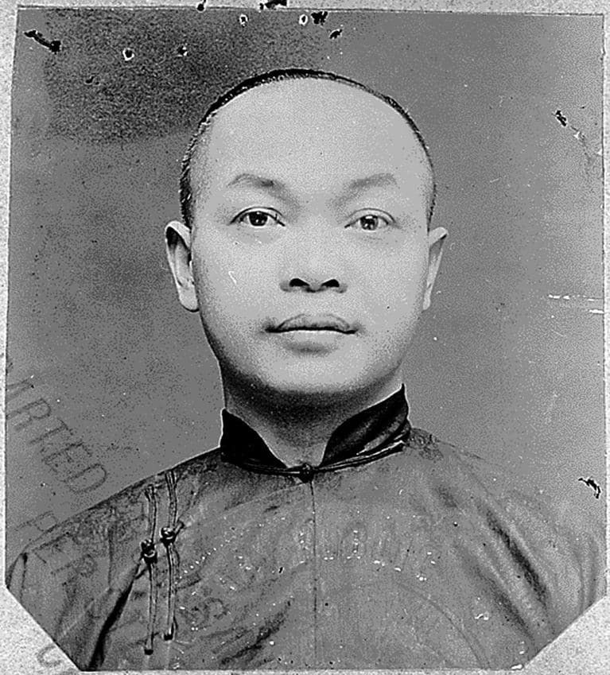
Facts of the case
The Chinese Exclusion Acts denied citizenship to Chinese immigrants. Moreover, by treaty no Chinese subject in the United States could become a naturalized citizen. Wong Kim Ark was born in San Francisco to parents who were both Chinese citizens who resided in the United States at the time. At age 21, he returned to China to visit his parents who had previously resided in the United States for 20 years. When he returned to the United States, Wong was denied entry on the ground that he was not a citizen.

Question
Is a child who was born in the United States to Chinese-citizen parents who are lawful permanent residents of the United States a U.S. citizen under the Citizenship Clause of the Fourteenth Amendment?

Conclusion
Because Wong was born in the United States and his parents were not “employed in any diplomatic or official capacity under the Emperor of China,” the Citizenship Clause of the Fourteenth Amendment automatically makes him a U.S. citizen. Justice Horace Gray authored the opinion on behalf of a 6-2 majority, in which the Court established the parameters of the concept known as jus soli—the citizenship of children born in the United States to non-citizens. This case will go on to set a precedent on citizenship in the United States, guaranteeing the rights of birthright citizenship for all.

Constitution of United States
Amendment XIV
Section 1.
All persons born or naturalized in the United States and subject to the jurisdiction thereof, are citizens of the United States and of the State wherein they reside. No State shall make or enforce any law which shall abridge the privileges or immunities of citizens of the United States; nor shall any State deprive any person of life, liberty, or property, without due process of law; nor deny to any person within its jurisdiction the equal protection of the law.

