Direction: Using the map on page 342 in your World History textbook to shade in the various geographic regions in Africa. Label the Atlantic, Pacific, and Indian Ocean. Locate and label the following regions: Sahara Desert, The Great Rift Valley, the Congo River, the Mediterranean Sea, the Nile River, and the Red Sea. Draw and label the Bantu Migration.
Vegetation Regions
Rain Forest
Savannah
Desert
Mediterranean
Dry Woodland
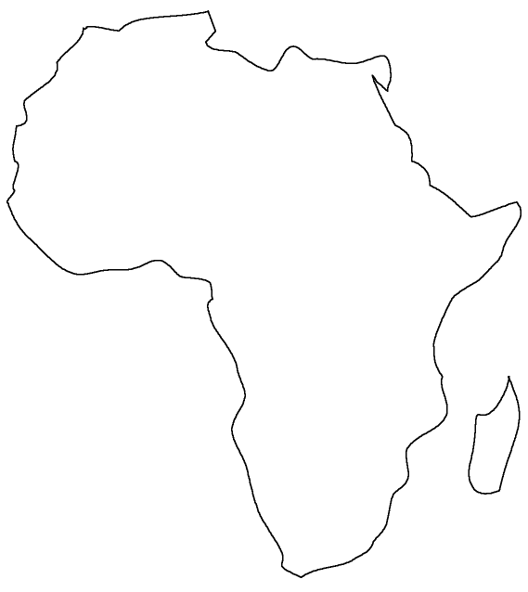

- Why do you think the Bantu-speakers migrated south in the pattern described instead of north?

- Using the information provided on the map, predict three areas where you think at trade settlement would most likely develop. Explain your reasoning.

Ancient African Civilizations

Cornell Notes of Early African Civilization
Main Ideas, key terms, questions | Record the lecture here, using bullet points, concise sentences, shorthand symbols, abbreviation
Early Civilizations of Africa  Geography  *desertification  *Bantu Migration  *cultural diffusion  Egyptian & Nubian Civilizations  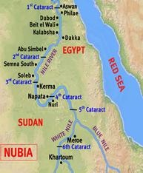  Outside influences affect North Africa  Phoenicians (Carthaginians)  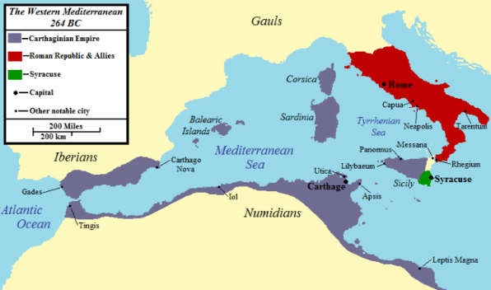  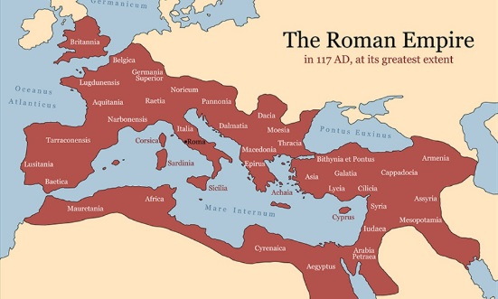  Romans  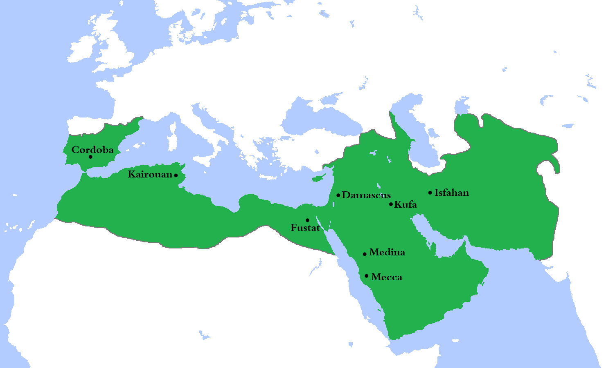  Arab/Islam  *Arabization  Kingdoms of West Africa  *savanna  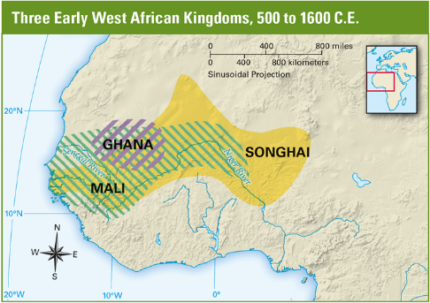  Ghana Empire  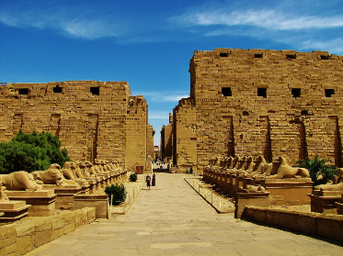  Mali Empire  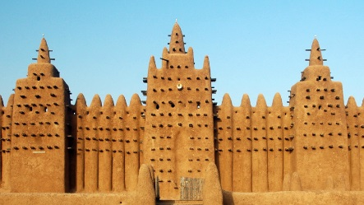  *syncretism  Mansa Musa  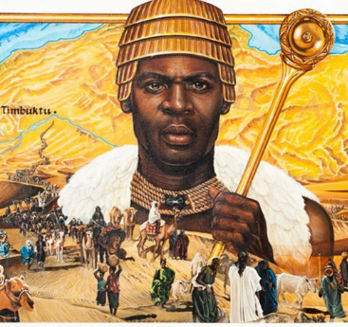  Songhai Empire  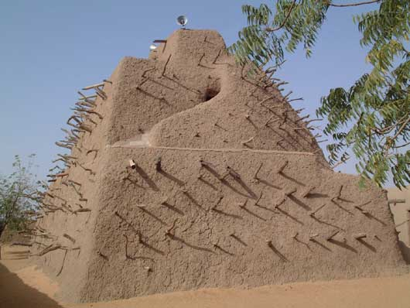  Kingdoms & Trading Sates of East Africa  Axum  Ethiopia  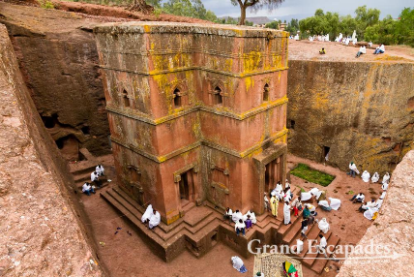  Swahili Coastal City-States  Kilwa, Mogadishu, Mombasa, Sofala  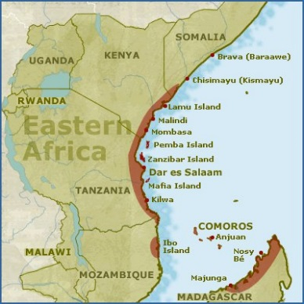  Great Zimbabwe  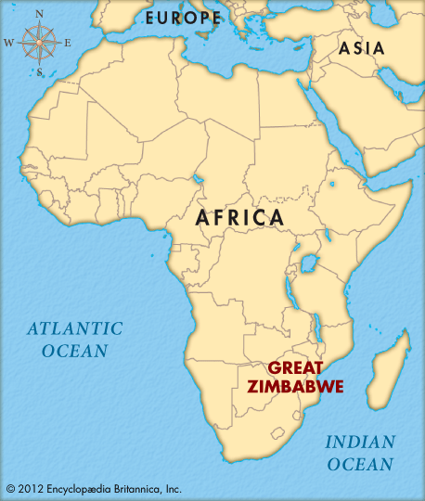 | - geography affected migration, cultural development & trade  - Sahara dried out people migrated out of region  - W. African farmers & herders (Bantu speakers) migrated south & east 100 BCE – 1000 CE

