Start of the Arms Race
On August 29, 1949 the Soviet Union successfully tested its first atomic bomb. The world was shocked. They did not think the Soviet Union was this far along in their nuclear development. The Arms Race had begun.

In 1952 the United States detonated the first hydrogen bomb. This was an even more powerful version of the nuclear bomb. The Soviets followed up by exploding their first hydrogen bomb in 1953.

ICBMs
In the 1950s both countries worked on developing Intercontinental Ballistic Missiles or ICBMs. These missiles could be launched from long range, as far away as 3,500 miles.

Defense
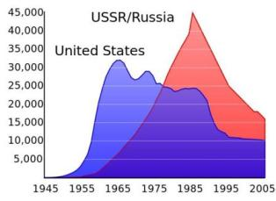
As both sides continued to develop new and more powerful weapons, the fear of what would happen if war broke out spread throughout the world. Militaries began to work on defenses such as large radar arrays to tell if a missile had been launched. They also worked on defense missiles that could shoot down ICBMs.

At the same time people built bomb shelters and underground bunkers where they could hide in the case of nuclear attack. Deep underground facilities were built for high ranking government officials where they could reside safely.

Mutual Assured Destruction
One of the major factors in the Cold War was termed Mutual Assured Destruction or MAD. This meant that both countries could destroy the other country in the case of attack. It wouldn't matter how successful the first strike was, the other side could still retaliate and destroy the country which first attacked. For this reason, neither side ever used nuclear weapons. The cost was too high.

Other Countries Involved
During the Cold War, three other nations also developed the nuclear bomb and had their own nuclear weapons. These included Great Britain, France, and the People's Republic of China.

Détente and Arms Reduction Talks
As the Arms Race heated up, it became very expensive for both countries. In the early 1970s both sides realized that something had to give. The two sides began to talk and take a softer line towards each other. This easing of relations was called détente.
In order to try and slow down the Arms Race, the countries agreed to reduce arms through the SALT I and SALT II agreements. SALT stood for Strategic Arms Limitation Talks.

End of the Arms Race
For the most part, the Arms Race came to an end with the collapse of the Soviet Union at the end of the Cold War in 1991.

Reading Questions
Why do you think ICBMs were built? What is it’s purpose?

Why did countries began to build more and more powerful nuclear weapons during the Cold War?

What is Mutual Assured Destruction?

What lead to the reduction of nuclear arms?

How did the Arms Race ended?
Following WWII, the U.S., Russia, the United Kingdom, France and China made treaties (agreements) to ONLY allow each other to have nuclear weapons. However, other counties have nuclear weapons without permission, because they don’t recognize the *NPT… which makes everyone a little uncomfortable.

Map of Nuclear-Armed Countries of the World.
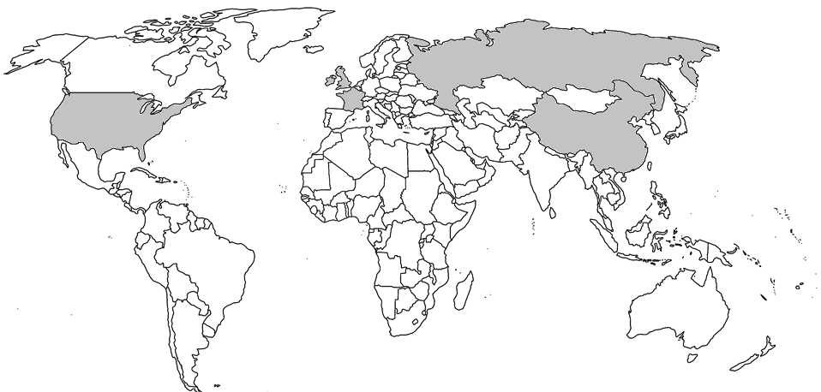
KEY:
- *NPT-designated nuclear weapon states (China, France, Russia, United Kingdom, United States)
- Other states with nuclear weapons (India, Pakistan, North Korea)
- Other states believed to have nuclear weapons (Israel)
- **NATO nuclear weapons sharing states (Belgium, Germany, Netherlands, Italy, Turkey)
- States formerly possessing nuclear weapons (Belarus, Kazakhstan, Ukraine, South Africa)

* Non-Proliferation Treaty or NPT, is an international treaty with the objective to prevent the spread of nuclear weapons and weapons technology, to promote cooperation in the peaceful uses of nuclear energy, and to further the goal of achieving nuclear disarmament and general and complete disarmament.
** The US, France and the United Kingdom store their nuclear weapons in these countries with the permission of the county’s government.

