Chinese Dynasty Autopsy
Directions: You and your partner will be investigating the success and eventual downfall of a Chinese Dynasty. You will be depicting this through an autopsy report. You will create a poster for one of the following civilizations:

Shang
Zhou
Qin
Han
Sui
Tang
Song
Yuan
Ming
Qing

Part One - Dynasty Obituary: You will create a clear picture of what this dynasty was like during healthier times, organized according to the following categories:
- Info section: Dynasty name, date (beginning & end), founder
- Head: Significant leaders & accomplishments
- Hands: Art & Literature, Architecture & Technology advances
- Legs: Labor systems
- Spine: Political structure, major political events/trends
- Ribs: Social structure
- Heart: Religious beliefs/philosophies
- Feet: Trade routes and goods traded
*Be creative- whenever possible, incorporate elements of your dynasty’s art, architecture, culture, etc.

Part Two - Dynasty Autopsy:
- What led to the decline of this dynasty?
- What weakened it?
- What led to their demise?
*Be creative- include illustrations or symbols representing the cause(s) of death.

Other Information:
- You need at least three sources of information from the library databases ONLY.
  - Start by using the sources linked on my website, this can count as one of the three required sources
- MLA Work Cited Page required
- Write your dynasty obituary information in one color.
- Write your dynasty autopsy info in a different color.
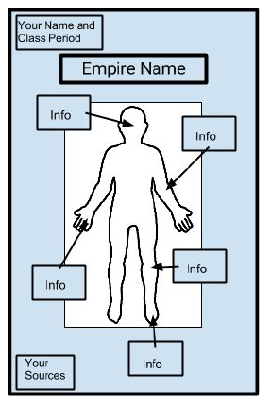
- Here’s a general idea:

NOTE: Your dynasty’s dead body is NOT naked. They are wearing clothes that would have been commonly worn during their life.

 | Exceeds Standards | Meets Standards | Approaching Standards | Below Standards
Part 1: Dynasty Obituary | All 8 categories on the poster with content that is:  - Accurate  - Detailed | All 8 categories on the poster with content that is:  - Accurate  - Adequate | Either there are less than 8 categories OR some of the content is:  - Inaccurate  - Lacking depth  - Lacking a few details | There are less than 8 categories AND content is:  - Inaccurate  - Lacks necessary detail  - Missing
Part 2: Dynasty Autopsy | Detailed and accurate account of the collapse of the dynasty in 5-7 complete sentences. | Accurate account of the collapse of the dynasty in 3-4 complete sentences | Either the information is less than 3 sentences OR it is written in bullet point format.  Some information may not be accurate. | The information is less than 3 sentences and written in bullet points.  Much of the information is not accurate.
Creativity & Organization | High level of effort apparent  Poster is colorful and creative  Content is easy to read and flows | Effort is apparent  Poster is colorful and gets the point across  Poster is organized  Content is easy to read | Effort is somewhat evident  Poster lacks color or creativity  Poster isn’t organized very well  Content is somewhat illegible | Effort is minimal or not evident  Poster has no color or creativity  Poster has no obvious organization  Content is illegible
Citation | More than 3 sources used.  No errors on the Work Cited page. | Three sources used.  1-2 errors in the Work Cited page. | Two sources used.  More than 2 errors on the Work Cited page. | No sources and/or no Work Cited page.

Total: ______ / 30

