Name: ____________________________________________ Per: ____
Primary Sources

Excerpts for the journal of Cristoforo Colombo (Christopher Columbus) on his trip to the New World
[Columbus often referred to himself and his men in 3rd person in his writing, he would refer to himself as, “the Admiral”]

Thursday 11 October (1492)
The land was first seen by a sailor called Rodrigo de Triana…

At two o'clock in the morning the land was discovered, at two leagues' distance…they found themselves near a small island, one of the Lucayos, called in the Indian language Guanahani. Presently they descried people, naked, and the Admiral landed in the boat, which was armed, along with Martin Alonzo Pinzon, and Vincent Yanez his brother, captain of the Nina.

…Numbers of the people of the island straightway collected together. Here follow the precise words of the Admiral: "As I saw that they were very friendly to us, and perceived that they could be much more easily converted to our holy faith by gentle means than by force, I presented them with some red caps, and strings of beads to wear upon the neck, and many other trifles of small value, wherewith they were much delighted, and became wonderfully attached to us. Afterwards they came swimming to the boats, bringing parrots, balls of cotton thread, javelins, and many other things which they exchanged for articles we gave them, such as glass beads, and hawk's bells; which trade was carried on with the utmost good will. But they seemed on the whole to me, to be a very poor people. They all go completely naked, even the women, though I saw but one girl. All whom I saw were young, not above thirty years of age, well made, with fine shapes and faces…

Weapons they have none, nor are acquainted with them, for I showed them swords which they grasped by the blades, and cut themselves through ignorance. They have no iron, their javelins being without it, and nothing more than sticks, though some have fish-bones or other things at the ends. They are all of a good size and stature, and handsomely formed. I saw some with scars of wounds upon their bodies, and demanded by signs the of them; they answered me in the same way, that there came people from the other islands in the neighborhood who endeavored to make prisoners of them, and they defended themselves. I thought then, and still believe, that these were from the continent. It appears to me, that the people are ingenious, and would be good servants and I am of opinion that they would very readily become Christians, as they appear to have no religion. They very quickly learn such words as are spoken to them. If it please our Lord, I intend at my return to carry home six of them to your Highnesses, that they may learn our language. I saw no beasts in the island, nor any sort of animals except parrots." These are the words of the Admiral.
.
What was Columbus’ first encounter with the native people of Guanahani like? How did they treat him?

How did Columbus perceive these people? What were his intentions towards them?

Excerpts for the journal of Cristoforo Colombo (Christopher Columbus) on his trip to the New World
[Columbus often referred to himself and his men in 3rd person in his writing, he would refer to himself as, “the Admiral”]

Sunday, 14 October (1492)
In the morning, I ordered the boats to be got ready, and coasted along the island toward the north- northeast to examine that part of it, we having landed first at the eastern part. Presently we discovered two or three villages, and the people all came down to the shore, calling out to us, and giving thanks to God. Some brought us water, and others victuals: others seeing that I was not disposed to land, plunged into the sea and swam out to us, and we perceived that they interrogated us if we had come from heaven. An old man came on board my boat; the others, both men and women cried with loud voices--"Come and see the men who have come from heavens. Bring them victuals and drink." There came many of both sexes, every one bringing something, giving thanks to God, prostrating themselves on the earth, and lifting up their hands to heaven. They called out to us loudly to come to land, but I was apprehensive on account of a reef of rocks, which surrounds the whole island…

…I do not, however, see the necessity of fortifying the place, as the people here are simple in war-like matters, as your Highnesses will see by those seven which I have ordered to be taken and carried to Spain in order to learn our language and return, unless your Highnesses should choose to have them all transported to Castile, or held captive in the island. I could conquer the whole of them with fifty men, and govern them as I pleased.

… the inhabitants [of these islands] living at war with one another, although a simple race, and with delicate bodies.

What was Columbus’ encounter with the native people like? How did they treat him?

How did Columbus perceive these people? What were his intentions towards them?

Excerpt from Columbus’s letter to Luis de Santangel (a patron who helped fund the first voyage)

…they are artless and generous with what they have, to such a degree as no one would believe but him who had seen it. Of anything they have, if it be asked for, they never say no, but do rather invite the person to accept it, and show as much lovingness as though they would give their hearts…

…their Highnesses [Queen and King of Spain] may see that I shall give them as much gold as they need .... and slaves as many as they shall order to be shipped.
.
According to this letter, how did Columbus perceive the native people of the Americas? What were his intentions towards them?

Excerpt from Michele de Cuneo’s Letter on the 2nd Voyage, 28 October 1495
(de Cuneo was a friend of Christopher Columbus and also fellow explorer .)

While I was in the boat I captured a very beautiful Carib woman, whom the said Lord Admiral [Christopher Columbus] gave to me, and with whom, having taken her into my cabin, she being naked according to their custom, I conceived desire to take pleasure. I wanted to put my desire into execution but she did not want it and treated me with her finger nails in such a manner that I wished I had never begun. But seeing that (to tell you the end of it all), I took a rope and thrashed her well, for which she raised such unheard of screams that you would not have believed your ears. Finally we came to an agreement in such manner that I can tell you that she seemed to have been brought up in a school of harlots.

According to Cuneo, what did the Admiral Columbus give to him?

What is being described in this letter?

Observations by Bartolome de las Casas from his book, “A Short Account of the Destruction of the Indies”, 1552
(Bartolome de Las Casas was a Spanish Catholic priest/missionary living in the Americas, this was written after he witnessed the cruelty against the Taino in the 1500s.

Since the Admiral [Columbus] perceived that daily the people of the land were taking up arms, ridiculous weapons in reality [wooden spears and bows]… he hastened [hurried] to proceed to the country and disperse and subdue, by force of arms, the people of the entire island… For this he chose 2000 foot soldiers and 20 cavalry [soldiers on horses], with many crossbows and small cannon, lances, and swords, and a still more terrible weapon against the Indians, in addition to the horses: this was 20 hunting dogs, who were turned loose and immediately tore the Indians apart…

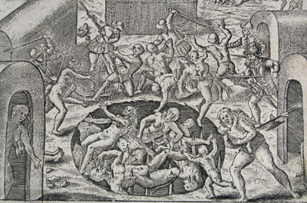
…And thus pregnant and nursing women and children and old persons and any others they might take, they would throw them into the holes until the pits were filled, the Indians pierced through by the stakes, which was a sore thing to see, especially the women with their children…

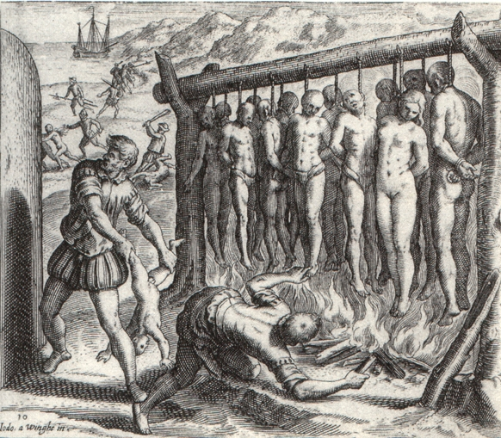

…They [the Conquistadors] would erect long gibbets (gallows)… and bind thirteen of the Indians at one time, in honour and reverence, they said, of Our Redeemer and the twelve Apostles, and put firewood around it and burn the Indians alive.

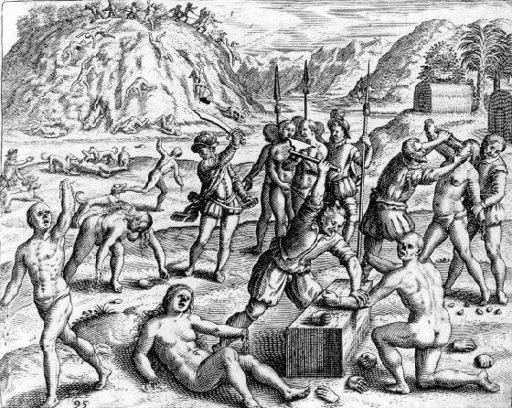
…Another time, because the Indians did not give him [Columbus] a coffer filled with gold… they killed an infinite number of souls, and cut off the hands and noses of countless women and men, and others they threw to the savage dogs, who ate them and tore them to pieces.

According to de las Casas, what did Columbus constantly fear? How did he deal with this fear?

What did the natives faces if they resisted or did not provide Columbus and his men with enough gold?

How does de las Casas depict Columbus? What kind of person is Christopher Columbus?

