Enlightenment Philosophers
Philosophers | Questions
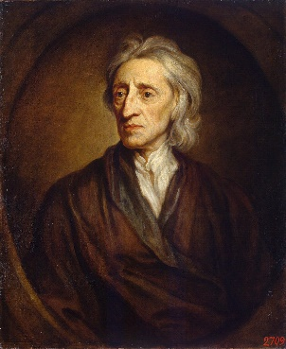  John Locke  To understand political power aright, we must consider what state all men are naturally in, and that is, a state of perfect freedom to order their actions and dispose of their possessions and persons, as they think fit, within the bounds of the law of nature; without asking leave, or depending upon the will of any other man. . . The state of nature has a law of nature to govern it, which obliges every one: and reason, which is that law, teaches all mankind, that being all equal and independent, no one ought to harm another in his life, health, liberty, or possessions…  - John Locke, On Civil Government  Whenever the legislators endeavor to take away and destroy the property of the people, or to reduce them to slavery under arbitrary power, they put themselves into a state of war with the people, who are thereupon absolved from any further obedience, and are left to the common refuge which God hath provided for all men against force and violence.  - John Locke, 2nd Treatise on Government | What does Locke say about the natural state of man?  What are his views on equality?  Should people ever rebel against the government? When?  What kind of government do you think Locke believes is ideal?
Dedirot  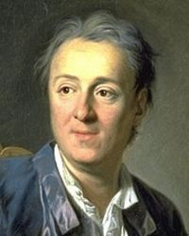  Doubts in religious matters, far from being blamable far from being acts of impiety, ought to be regarded as praiseworthy, when they proceed from a man who humbly acknowledges his ignorance, and arise from the fear of offending God by the abuse of reason.  To admit any conformity (traditions) between the reason of man, and the eternal reason of God, and to pretend that God demands the sacrifice of human reason, is to maintain that God wills one thing, and intends another thing at the same time.  When God, of whom I hold my reason, demands of me to sacrifice it, he becomes a mere juggler that snatches from me what he pretended to give.  If I renounce my reason, I have no longer a guide. I must then blindly adopt a secondary principle, and the matter in question becomes a supposition….  - Denis Diderot, La Religieuse (The Memoirs of a Nun). Written 1780, published 1796. | What does Dedirot think about reason and religion?  Why does Dedirot value reason so much?
Baron de Montesquieu  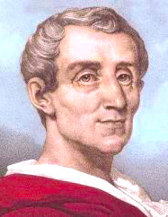  Political liberty is to be found only in moderate governments; and even in these it is not always found. It is there only when there is no abuse of power: but constant experience shows us that every man invested with power is apt to abuse it, and to carry his authority as far as it will go. To prevent this abuse, it is necessary, from the very nature of things, that power should be a check to power.  When the legislative and executive powers are united in the same person, or in the same body of magistrates, there can be no liberty. . . . Again, there is no liberty if the judiciary power be not separated from the legislative and executive.  - Baron de Montesquieu, Of Political Liberty and the Constitution of England | What does he say about abusing power?  How can the abuse of power be avoided?  What kind of government do you think Montesquieu believes is ideal?
Jean Jacques Rousseau  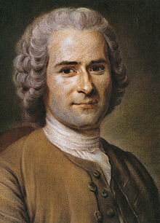  Man is born free; and everywhere he is in chains. How did this change come about?...at some time mankind reached a point when the disadvantages of remaining in a state of nature outweighed the advantages.  …Some type of agreement must be found which can rally the whole community together for the protection of the person and property of each of its citizens in such a way that each man, because he is a voluntary member of the agreement, still obeys his own will and hence remains as free as he was before. This type of agreement can be found in the social contract.  The essence of the social contract may be stated simply: Each individual surrenders all his rights to the community. Since each man surrenders his rights without reservation, all are equal. And because all are equal, it is to everyone’s interest to make life pleasant for his fellows.  - Jean Jacques Rousseau, The Social Contract | What does he say about the natural state of man?  What does he mean by “social contract”?  What might be the advantages and disadvantages of the social contract?  What kind of government do you think Rousseau believes is ideal?
Mary Wollstonecraft  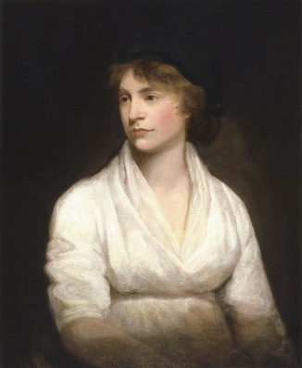  … 'Educate women like men,' says Rousseau, 'and the more they resemble our sex the less power will they have over us.' This is the very point I aim at. I do not wish them [women] to have power over men; but over themselves.  In the same strain have I heard men argue against instructing the poor; for many are the forms that aristocracy assumes. 'Teach them to read and write,' say they, 'and you take them out of the station assigned them by nature.' An eloquent Frenchman has answered them, I will borrow his sentiments. But they know not, when they make man a brute, that they may expect every instant to see him transformed into a ferocious beast. Without knowledge there can be no morality!  Ignorance is a frail base for virtue! Yet, that it is the condition for which woman was organized, has been insisted upon by the writers who have most vehemently argued in favour of the superiority of man…  - Mary Wollstonecraft, The Vindication of the Rights of Women. 1792 | Why does Wollstonecraft believe education is so important?  How does she think education will help women?
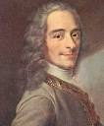  Voltaire  The Church is the assembly of all the faithful summoned on certain days to pray in common, and at all times to do good actions.…  …It is no less evident that if the ecclesiastics, who are part of civil society, had acquired rights which might trouble or destroy society, these rights ought to be suppressed.  It is still more evident that, if God has attached to the Church prerogatives or rights, neither these rights nor these prerogatives should belong exclusively either to the chief of the Church or to the ecclesiastics, because they are not the Church, just as the magistrates are not the sovereign in either a democratic state or in a monarchy.…  …Obedience to ecclesiastical order must consequently always be free and voluntary: no other should be possible. Submission, on the other hand, to civil order may be coerced and compulsory.  For the same reason, ecclesiastical punishments, always spiritual, do not reach here below any but those who are convinced inwardly of their fault. Civil pains, on the contrary, accompanied by a physical ill, have their physical effects, whether or no the guilty recognize their justice.  From this it results obviously that the authority of the clergy is and can be spiritual only; that it should not have any temporal power; that no coercive force is proper to its ministry, which would be destroyed by it.  It follows from this further that the sovereign, careful not to suffer any partition of his authority, must permit no enterprise which puts the members of society in external and civil dependence on an ecclesiastical body.  - Voltaire, Dictionnaire philosophique (Philosophical Dictionary), 1764 | What does Voltaire believes is the role of the Church?  Should the Church have any authority in civil matters, according to Voltaire?  What concept is this called?

