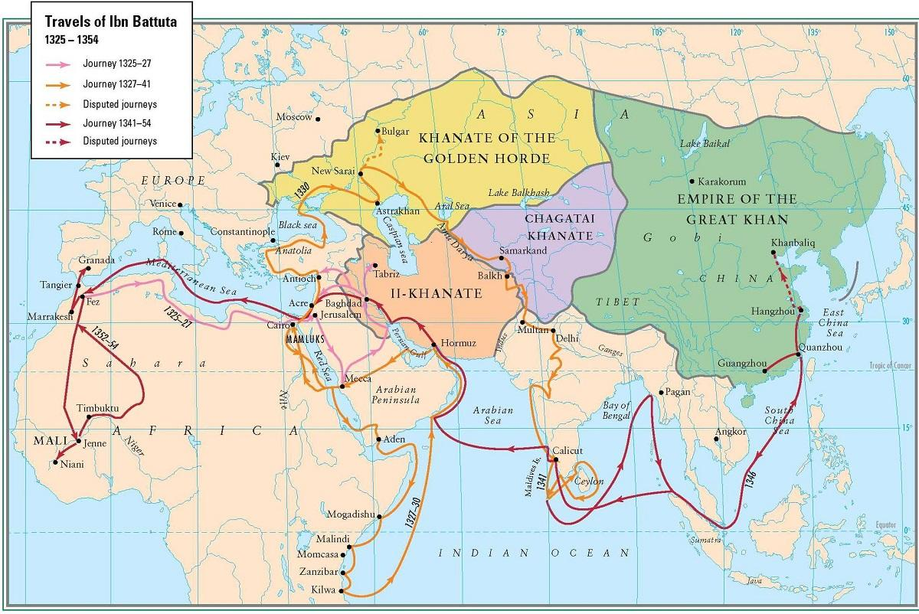
Ibn Battuta Comic Strip
Gilpin/Nguyen Freshman Humanities
Assignment: Research the travels of Ibn Battuta. Create a comic strip depicting one place he traveled to show your understanding of graphic terminology.

Content Requirements
Visit https://orias.berkeley.edu/resources-teachers/travels-ibn-battuta (or google “Berkeley Ibn Battuta”). On the left, there is a list of links, each one focusing on a different destination of Ibn Battuta. Choose whichever is interesting to you, and create a comic strip depicting it.
To meet standards, your comic must:
- Show the most important events of that journey, using both words and art.
To exceed standards, your comic must:
- Highlight the cultural practices (especially religious practices, if applicable) of the people he encountered.
- Include Ibn Battuta’s opinions, either paraphrased or directly quoted. Be sure to use quotation marks inside your speech balloons if you are directly quoting.
Reminder! Although your comic may depict Ibn Battuta and the people he met on his journey, and may use religious symbols to represent Islam or aspects of Islam, your comic must not depict Muhammad, the founder and prophet of Islam. Although religious law concerning depicting Muhammad has evolved over time, “In modern times … the physical depiction of the Prophet has become an increasingly sensitive issue. This holds especially true for modern media such as films, where hardly any serious attempt was made to put Muhammad onscreen” (Brunner 132). In this class we want to respect this cultural belief and therefore you should not draw Muhammad himself. If you have questions on what is acceptable to include in your comic, please don’t hesitate to ask! ☺
Comic Strip Requirements
To meet standards, your comic strip must use an 11x17” piece of paper (do not cut the paper), and include (with annotations):
  - A plot (remember, a graphic novel is sequential art!)
  - 6 or more panels.
  - Gutters between panels.
  - At least two captions.
  - At least two speech balloons.
  - At least three emanata.
  - At least two different types of transitions (pick any out of the 6).
  - Line work must be in pen or marker (you can start with pencil and trace over.)
To exceed standards, also include:
- A splash or bleed panel.
- Panels that include panel depth – items in the foreground/midground/background.
- Color.
FOR FULL POINTS, you must annotate your comic with all of this graphic terminology!!!
(Label each thing, point them out with arrows, etc! For example, when you include a caption, also point to that caption with a little note that says “caption →”). Make sure it’s easy to see your annotations. If you’re not sure if they’re visible, highlight them!

Example (copy the annotations Ms. Gilpin provides under the doc cam!):
