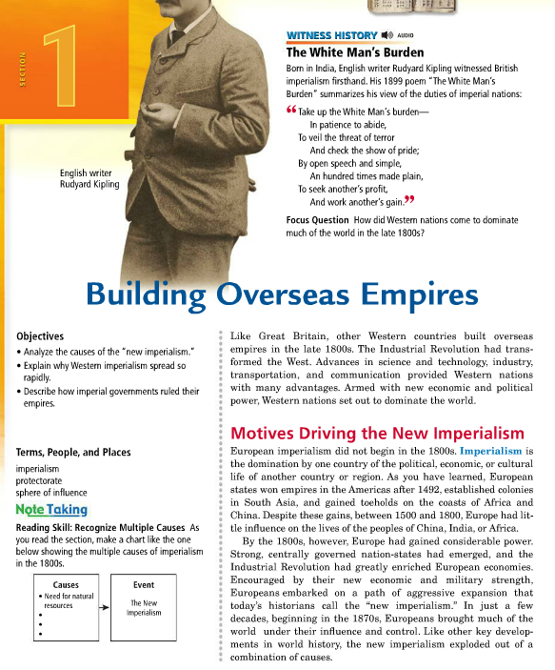 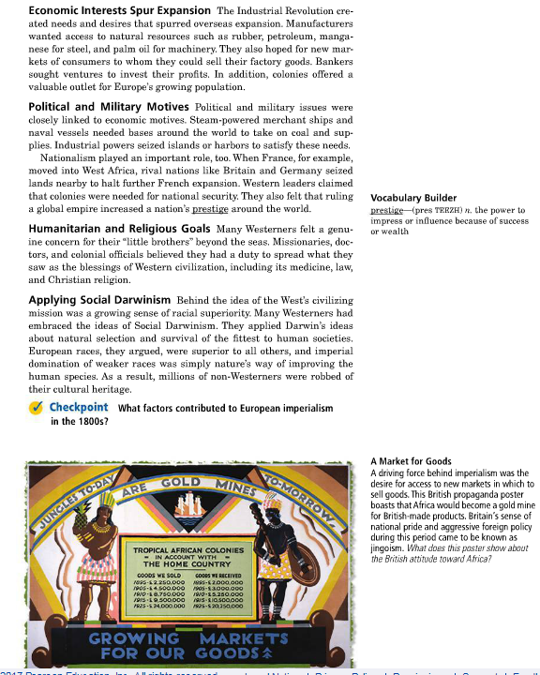

**Direction**:

1. Highlight/underline the definition of imperialism
2. Highlight/underline (different color) AND annotate (make notes on the side) the answer this question: **What were the causes for imperialism?**
3. Highlight/underline (different color) AND annotate (make notes on the side) the answer this question: **What were different forms of imperialism?**
4. Answer any m argin questions.

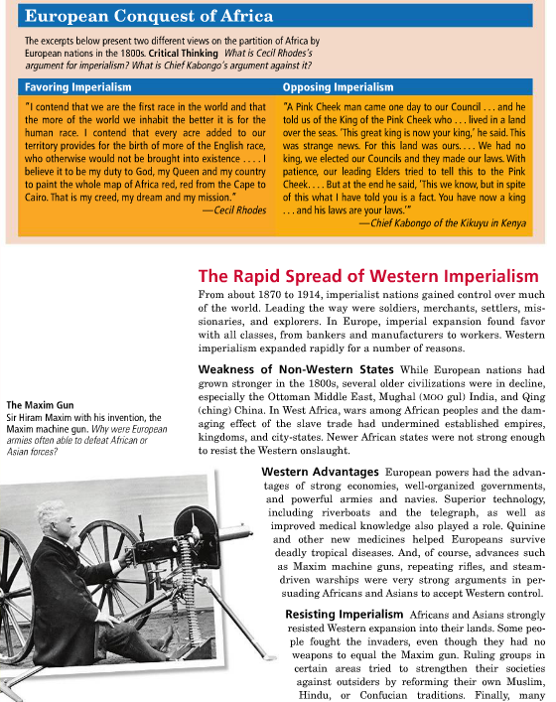

**What is Chief Kabongo saying in this passage?**

**What idea is being conveyed in this Cecil Rhodes’ passage for imperialism?**

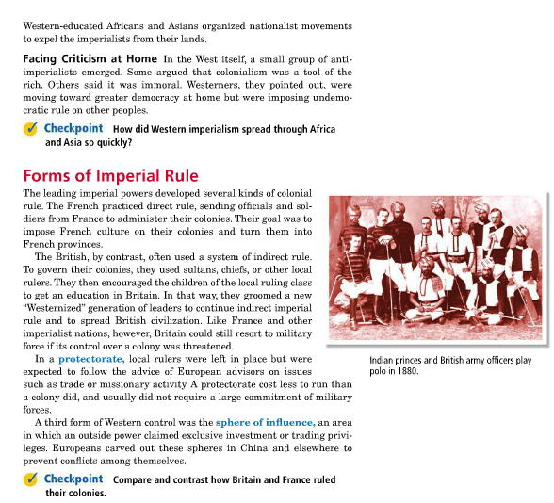

**What is the advantages/disadvantages of direct rule?**

**What is the advantages/disadvantages of indirect rule?**