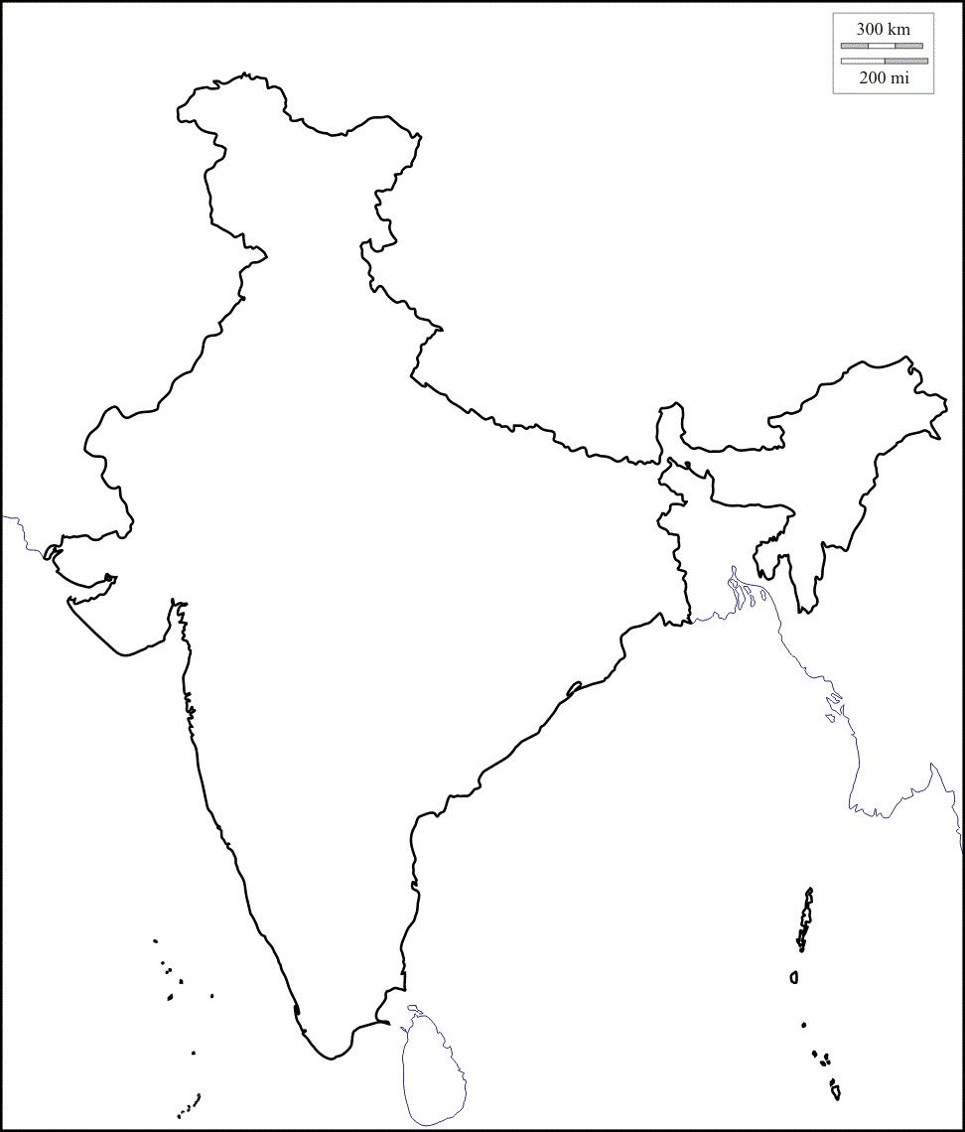

Direction: Using the map on page 68, label the following:

* geographical features: Himalayas Mountain Range, Gangetic Plain, Deccan Plateau, Eastern Ghats, Western Ghats, Thar Desert, Hindu Kush Mountain Range, Vindhya Mountains
* body of water: Indus River, Ganges River, Narmada Rivers, Brahmaputra River, Bay of Bengal, Indian Ocean, Arabian Sea

Using a single color pencil, shade in the Indus Civilization and label the two cities: Mohenjo-Daro and Harappa

**Geographical Map of India**