Iranian Revolution
Iranian Revolution, also called Islamic Revolution, Persian Enqelāb-e Eslāmī, popular uprising in Iran in 1978–79 that resulted in the toppling of the monarchy on February 11, 1979, and led to the establishment of an Islamic republic.

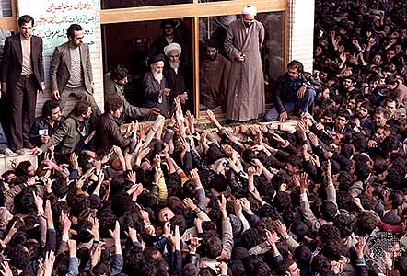
Prelude to revolution
The 1979 revolution, which brought together Iranians across many different social groups, has its roots in Iran’s long history. These groups, which included clergy, landowners, intellectuals, and merchants, had previously come together in the Constitutional Revolution of 1905–11. Efforts toward satisfactory reform were continually stifled, however, amid reemerging social tensions as well as foreign intervention from Russia, the United Kingdom, and, later, the United States. The United Kingdom helped Reza Shah Pahlavi establish a monarchy in 1921. Along with Russia, the U.K. then pushed Reza Shah into exile in 1941, and his son Mohammad Reza Pahlavi took the throne. In 1953, amid a power struggle between Mohammed Reza Shah and Prime Minister Mohammad Mosaddegh, the U.S. Central Intelligence Agency (CIA) and the U.K. Secret Intelligence Service (MI6) orchestrated a coup against Mosaddegh’s government.
Ruhollah Khomeini (centre) greeting supporters after returning to Tehrān, February 1979.
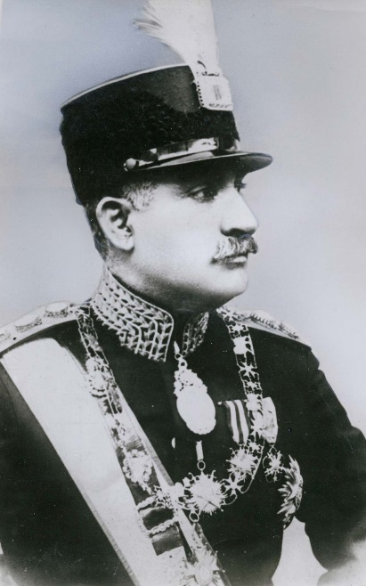
Years later, Mohammad Reza Shah dismissed the parliament and launched the White Revolution—an aggressive modernization program that upended the wealth and influence of landowners and clerics, disrupted rural economies, led to rapid urbanization and Westernization, and prompted concerns over democracy and human rights. The program was economically successful, but the benefits were not distributed evenly, though the transformative effects on social norms and institutions were widely felt. Opposition to the shah’s policies was accentuated in the 1970s, when world monetary instability and fluctuations in Western oil consumption seriously threatened the country’s economy, still directed in large part toward high-cost projects and programs. A decade of extraordinary economic growth, heavy government spending, and a boom in oil prices led to high rates of inflation and the stagnation of Iranians’ buying power and standard of living.
In addition to mounting economic difficulties, sociopolitical repression by the shah’s regime increased in the 1970s. Outlets for political participation were minimal, and opposition parties such as the National Front (a loose coalition of nationalists, clerics, and noncommunist left-wing parties) and the pro-Soviet Tūdeh (“Masses”) Party were marginalized or outlawed. Social and political protest was often met with censorship, surveillance, or harassment, and illegal detention and torture were common.
Reza Shah Pahlavi
For the first time in more than half a century, the secular intellectuals—many of whom were fascinated by the populist appeal of Ayatollah Ruhollah Khomeini, a former professor of philosophy in Qom who had been exiled in 1964 after speaking out harshly against the shah’s recent reform program—abandoned their aim of reducing the authority and power of the Shiʿi ulama (religious scholars) and argued that, with the help of the ulama, the shah could be overthrown.
In this environment, members of the National Front, the Tūdeh Party, and their various splinter groups now joined the ulama in broad opposition to the shah’s regime. Khomeini continued to preach in exile about the evils of the Pahlavi regime, accusing the shah of irreligion and subservience to foreign powers. Thousands of tapes and print copies of Khomeini’s speeches were smuggled back into Iran during the 1970s as an increasing number of unemployed and working-poor Iranians—mostly new migrants from the countryside, who were disenchanted by the cultural vacuum of modern urban Iran—turned to the ulama for guidance. The shah’s dependence on the United States, his close ties with Israel—then engaged in extended hostilities with the overwhelmingly Muslim Arab states—and his regime’s ill-considered economic policies served to fuel the potency of dissident rhetoric with the masses.
Outwardly, with a swiftly expanding economy and a rapidly modernizing infrastructure, everything was going well in Iran. But in little more than a generation, Iran had changed from a traditional, conservative, and rural society to one that was industrial, modern, and urban. The sense that in both agriculture and industry too much had been attempted too soon and that the government, either through corruption or incompetence, had failed to deliver all that was promised was manifested in demonstrations against the regime in 1978.

Revolution
In January 1978, incensed by what they considered to be slanderous remarks made against Khomeini in Eṭṭelāʿāt, a Tehrān newspaper, thousands of young madrasah (religious school) students took to the streets. They were followed by thousands more Iranian youth—mostly unemployed recent immigrants from the countryside—who began protesting the regime’s excesses. The shah, weakened by cancer and stunned by the sudden outpouring of hostility against him, vacillated between concession and repression, assuming the protests to be part of an international conspiracy against him. Many people were killed by government forces in anti-regime protests, serving only to fuel the violence in a Shiʿi country where martyrdom played a fundamental role in religious expression. Fatalities were followed by demonstrations to commemorate the customary 40-day milestone of mourning in Shiʿi tradition, and further casualties occurred at those protests, mortality and protest propelling one another forward. Thus, in spite of all government efforts, a cycle of violence began in which each death fueled further protest, and all protest—from the secular left and religious right—was subsumed under the cloak of Shiʿi Islam and crowned by the revolutionary rallying cry Allāhu akbar (“God is great”), which could be heard at protests and which issued from the rooftops in the evenings.
The violence and disorder continued to escalate. On September 8 the regime imposed martial law, and troops opened fire against demonstrators in Tehrān, killing dozens or hundreds. Weeks later, government workers began to strike. On October 31, oil workers also went on strike, bringing the oil industry to a halt. Demonstrations continued to grow; on December 10, hundreds of thousands of protesters took to the streets in Tehrān alone.
During his exile, Khomeini coordinated this upsurge of opposition—first from Iraq and after 1978 from France—demanding the shah’s abdication. In January 1979, in what was officially described as a “vacation,” the shah and his family fled Iran. The Regency Council established to run the country during the shah’s absence proved unable to function, and Prime Minister Shahpur Bakhtiar, hastily appointed by the shah before his departure, was incapable of effecting compromise with either his former National Front colleagues or Khomeini. Crowds in excess of one million demonstrated in Tehrān, proving the wide appeal of Khomeini, who arrived in Iran amid wild rejoicing on February 1. Ten days later, on February 11, Iran’s armed forces declared their neutrality, effectively ousting the shah’s regime. Bakhtiar went into hiding, eventually to find exile in France.

Aftermath
On April 1, following overwhelming support in a national referendum, Khomeini declared Iran an Islamic republic. Elements within the clergy promptly moved to exclude their former left-wing, nationalist, and intellectual allies from any positions of power in the new regime, and a return to conservative social values was enforced. The Family Protection Act (1967; significantly amended in 1975), which provided further guarantees and rights to women in marriage, was declared void, and mosque-based revolutionary bands known as komītehs (Persian: “committees”) patrolled the streets enforcing Islamic codes of dress and behaviour and dispatching impromptu justice to perceived enemies of the revolution. Throughout most of 1979 the Revolutionary Guards—then an informal religious militia formed by Khomeini to forestall another CIA-backed coup as in the days of Mosaddegh—engaged in similar activity, aimed at intimidating and repressing political groups not under the control of the ruling Revolutionary Council and its sister Islamic Republican Party, both clerical organizations loyal to Khomeini. The violence and brutality often exceeded that which had taken place under the shah.
The militias and the clerics they supported made every effort to suppress Western cultural influence, and, facing persecution and violence, many of the Western-educated elite fled the country. This anti-Western sentiment eventually manifested itself in the November 1979 seizure of 66 hostages at the U.S. embassy by a group of Iranian protesters demanding the extradition of the shah, who at that time was undergoing medical treatment in the United States (see Iran hostage crisis). Through the embassy takeover, Khomeini’s supporters could claim to be as “anti-imperialist” as the political left. This ultimately gave them the ability to suppress most of the regime’s left-wing and moderate opponents.
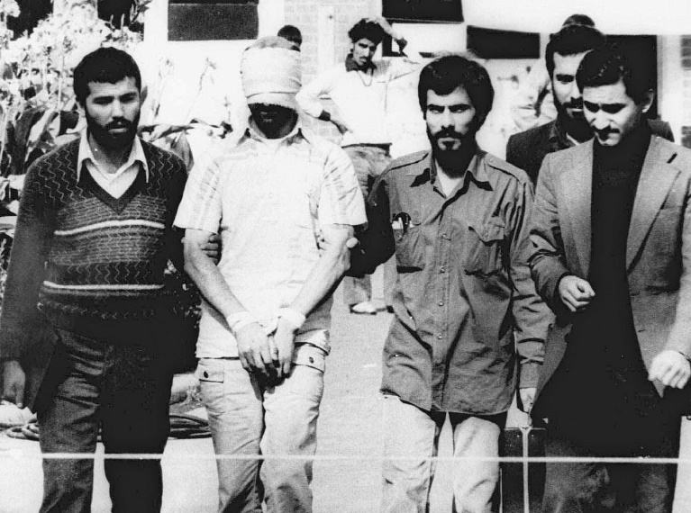
The Assembly of Experts (Majles-e Khobregān), overwhelmingly dominated by clergy, put a new constitution to referendum the following month, and it was overwhelmingly approved. The new constitution created a religious government based on Khomeini’s vision of velāyat-e faqīh (Persian: “governance of the jurist”) and gave sweeping powers to the rahbar, or leader; the first rahbar was Khomeini himself. Moderates, such as provisional Prime Minister Mehdi Bazargan and the republic’s first president, Abolhasan Bani-Sadr, who opposed holding the hostages, were steadily forced from power by conservatives within the government who questioned their revolutionary zeal.
Tehrān: U.S. embassy hostages
Blindfolded American hostage with his Iranian captors outside the U.S. embassy in Tehrān, November 9, 1979.

On a separate sheet of paper, write the question out & answer the following reading Questions:
- Describe the role that the West (Russia, the United Kingdom (Britain) and the United State) played in Iran in the prelude to revolution.
- What was the White Revolution? (*The documentary called it the King’s Revolution).
- Which three social classes (within Iran) that disapproved of the Shah’s government?
- Despite the economic success of the Shah’s aggressive modernization program, why were the Iranian people unhappy with his rule. List all of the reasons.
- Why did the secular intellectuals support the Ayatollah?
- What happened to the secular intellectuals (article also refers to them as left-wing) after the Revolution?
- Describe the Revolutionary Guard.
- What was Iran’s views and sentiments (feelings) towards the West and Western ideas after the Revolution?
- What was the Assembly of Experts? What was their impact on the development of the new Islamic republic?

