Modern countries:
Argentina
Bolivia
Brazil
Chile
Columbia
Costa Rica
Cuba
Ecuador
El Salvador
Guatemala
Haiti
Mexico
Nicaragua
Panama
Paraguay
Peru
Uruguay
Venezuela

Cities:
Bogotá
Buenos Aires
Caracas
Havana
Lima
Mexico City
Montevideo
Port-au-Prince
Rio De Janeiro
Santiago
São Paulo

Bodies of water:
Amazon River
Atlantic Ocean
Pacific Ocean
Panama Canal

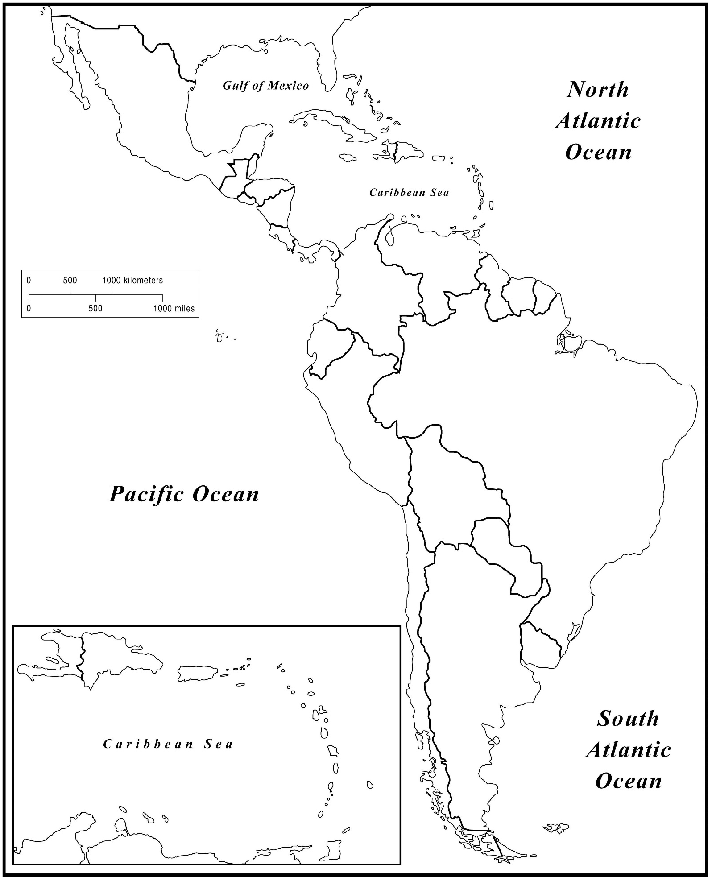
Map of Latin of America

