Map of Europe
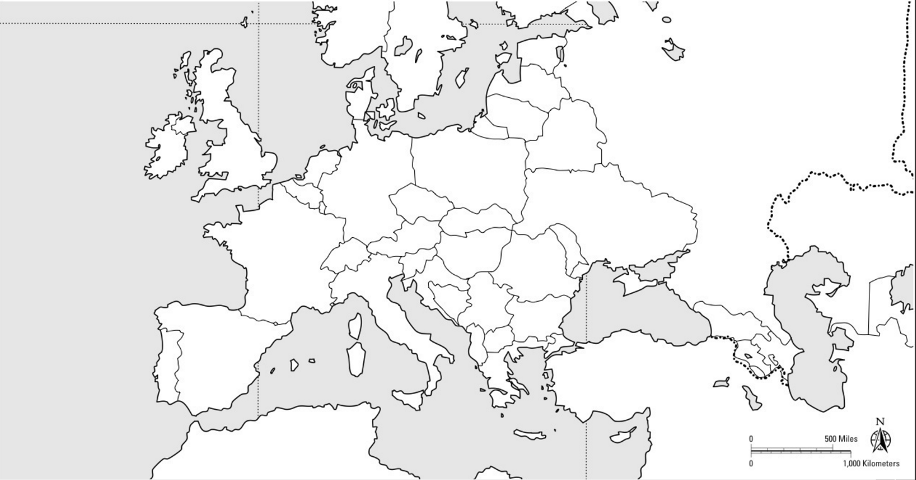
88068

Map of Europe Instructions
Label the following cities AND their country on your map:

London
Paris
Versailles
Moscow
St. Petersburg
Rome
Florence
Berlin
Warsaw
Vienna
Munich
Prague
Dublin
Stockholm
Amsterdam
Sarajevo
Madrid
Istanbul

