Name: ___________________________________________ Per: ___
Direction: Read both the excerpts from Karl Marx’s “The Communist Manifesto” and Adam Smith’s “The Wealth of Nations”. Fill out the graphic organizer for each.

Karl Marx’s “The Communist Manifesto” | Adam Smith’s “The Wealth of Nations”.
Date:  Summary: (in your own words, explain what the author is saying, look up any words you do not know!!)  Who was Karl Marx? What do you know about his background?  Who do you think was Marx’ intended audience? Why?  Why would the Marx write/produce this document?  How did Marx response to industrialization of the 18th and 19th century? (write on the back if you need more space) | Date:  Summary: (in your own words, explain what the author is saying, look up any words you do not know!!)  Who was Adam Smith? What do you know about his background?  Who do you think was Smith’s intended audience? Why?  Why would the Smith write/produce this document?  How did Smith response to industrialization of the 18th and 19th century? (write on the back if you need more space)
Document 1 – Karl Marx
Source: Karl Marx, German philosopher and political organizer, The Manifesto of the Communist Party, 1848.

Owing to the extensive use of machinery, and to the division of labor, the work of the proletarians has lost all individual character, and, consequently, all charm for the workman. He becomes an appendage of the machine, and it is only the most simple, most monotonous, and most easily acquired knack, that is required of him…

Modern Industry has converted the little workshop of the patriarchal master into the great factory of the industrial capitalist. Masses of laborers, crowded into the factory, are organized like soldiers. As privates of the industrial army, they are placed under the command of a perfect hierarchy of officers and sergeants. Not only are they slaves of the bourgeois class, and of the bourgeois state; they are daily and hourly enslaved by the machine, by the overlooker, and, above all, in the individual bourgeois manufacturer himself…

The less the skill and exertion of strength implied in manual labor, in other words, the more modern industry becomes developed, the more is the labor of men superseded by that of women. Differences of age and sex have no longer any distinctive social validity for the working class. All are instruments of labor, more or less expensive to use, according to their age and sex...

In short, the Communists everywhere support every revolutionary movement against the existing social and political order of things…

The Communists disdain to conceal their views and aims. They openly declare that their ends can be attained only by the forcible overthrow of all existing social conditions. Let the ruling classes tremble at a communist revolution. The proletarians have nothing to lose but their chains. They have a world to win.

Working men of all countries, unite!
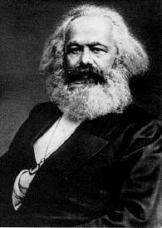
Karl Marx
- “Father of communism”
- Born in Germany but spent much of his time in England, where he witnesses the brutal conditions for the working classes brought by the Industrial Revolution
- Believed that history could be understood through class struggle, (a continuous conflict between the owner and workers) and the industrial revolution/capitalism intensified this conflict.
- Was critical of capitalism because he believed it led to a “dictatorship of the bourgeoisie,” meaning that the wealthy, owning class (bourgeoisie) controlled the economy for their own benefit.
- Marx argued that capitalism would inevitably collapse because the working classes (proletarians) would lead a revolutionary struggle
- After the revolution, Marx believed a classless socialist society would be created.

Document 2 – Adam Smith

Source: Adam Smith, Scottish economist, excerpts from The Wealth of Nations published in 1776

…All systems either of preference or of restraint, therefore, being thus completely taken away, the obvious and simple system of natural liberty establishes itself of its own accord. Every man, as long as he does not violate the laws of justice, is left perfectly free to pursue his own interest his own way, and to bring both his industry and capital into competition with those of any other man, or order of men.

The sovereign is completely discharged from a duty, in the attempting to perform which he must always be exposed to innumerable delusions, and for the proper performance of which no human wisdom or knowledge could ever be sufficient; the duty of superintending the industry of private people, and of directing it towards the employments most suitable to the interest of the society...

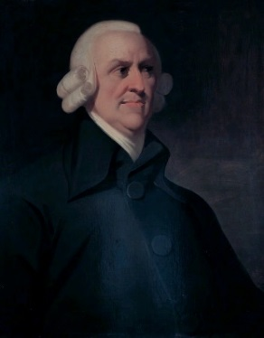
Adam Smith
- From Scotland and considered “father of capitalism”
- Wrote The Wealth of Nations in 1776 explaining your economic theories
- Believed strongly that the government should take a laissez faire (hands-off) approach to business and the market place meaning that the government shouldn’t pass laws that interfere with the free market
- Also believed that if everyone acts in their own self-interest it will benefit the nation because competition will make workers and factory owners more efficient and drive down prices.

