Document 1:
In The Middle Ages, historian Frantz Funck-Brentano made use of previously published texts to describe Europe in the ninth and tenth centuries (Heinemann, 1922, pp. 1-3).
The barbarians have broken through the ramparts. The Saracen [Moors] invasions have spread in successive waves over the South. The Hungarians swarm over the Eastern provinces ... they sacked town and village, and laid waste the fields. They burned down the churches and then departed with a crowd of captives.... There is no longer any trade, only unceasing terror .... The peasant has abandoned his ravaged fields to avoid the violence of anarchy. The people have gone to cower in the depths of the forests or in inaccessible regions, or have taken refuge in the high mountains .... Society has no longer any government. ...

Document 2:
This excerpt is from the Homage Oath taken by John of TouL
I, John of Toul, make known that I am the liege man of the [count and countess of Champagne].... I will aid the count of Champagne in my own person, and will send to the count and countess of Champagne the knights whose service I owe to them for the fief which I hold of them...."

Document 3:
The Anglo-Saxon Chronicle tells of invasions of England.
846: In this year there was a great slaughter in London and Quentavic and in Rochester.
846: According to their custom the Northmen plundered ... and burned the town of Dordrecht.... the Northmen, with their boats filled with immense booty, including both men and goods, returned to their own country....

Document 4:
From John Greene’s Crash Course History on the Middle Ages
“One more point that’s very interesting from a world history perspective: this devolution from empire to localism has happened in lots of places at lots of different times. And in times of extreme political stress, like after the fall of the Han dynasty in China, power tends to flow into the hands of local lords who can protect the peasants better than the state can.”

Document 5:
A Church council calls for the observance of the Truce of God, 1083 .
. . That from the first day of the Advent of our Lord through Epiphany ... and throughout the year on every Sunday, Friday, and Saturday, and on the fast days of the four seasons ... this decree of peace shall be observed ... so that no one may commit murder, arson, robbery, or assault, no one may injure another with a sword, club, or any kind of weapon.... On ... every day set aside, or to be set aside, for fasts or feasts, arms may be carried, but on this condition, that no injury shall be done in any way to anyone ... If it shall happen that any castle is besieged during the days which are included within the peace, the besiegers shall cease from attack unless they are set upon by the beseiged and compelled to beat the latter back ....

Document 6:
This excerpt describes the Middle Ages. (From Gray C Boyce, "The Medieval Period" in The 34th Yearbook oj the National Council for the Social Studies, 1964, pp. 69-70.)
... we learn that an age once traditionally described as "dark" had remarkable vitality and exuberance. Even at its worst it performed the function of guarding, frequently by accident and chance, the knowledge and treasures of what had come before, but even more it was creative and inventive, and transmitted to later ages great riches of its own.

Document 7:
This description of the positive aspects of the Middle Ages was taken from Medieval Europe by H. C Davis, Oxford University Press, 1946, p. 79 .
. . Medieval culture was imperfect, was restricted to a narrow circle of superior minds .... Measure it, however, by the memories and the achievements that it has bequeathed to the modern world, and it will be found not unworthy to rank with those of earlier and later Golden Ages. It flourished in the midst of rude surroundings, fierce passions, and material ambitions ... we must judge of them by their philosophy and law, by their poetry and architecture... .

Document 8:
This excerpt is from the monastic vows of Brother Gerald.
I herby renounce my parents, my brothers and relatives, my friends, my possessions ...and the vain and empty glory and pleasure of this world. I also renounce my own will, for the will of God. I accept all the hardships of the monastic life, and take the vows of purity, chastity and poverty, in the hope of heaven; and I promise to remain a monk in this monastery all the days of my life.

Document 9:
In 1095, Pope Urban II issued a call for a holy crusade-a war to recapture the Holy Land
. . . Your brethren who live in the [Middle] East are in urgent need of your help.... For, as most of you have heard, the Turks and the Arabs have attacked them and have conquered the territory of Romania [the Byzantine Empire] .... They have occupied more and more of the lands of those Christians .... They have killed and captured many, and have destroyed the churches and devastated the Empire .... All who die by the way, whether by land or sea, or in battle against the pagans, shall have immediate remission of sins.
Document 10:
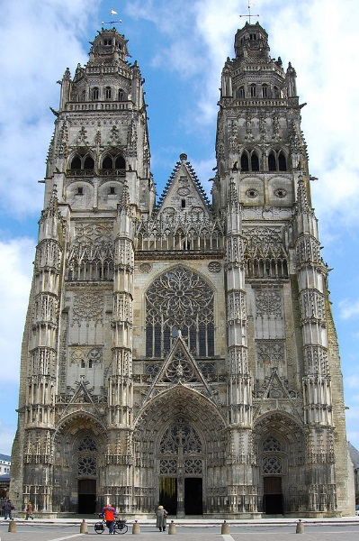  The Cathedral of Saint-Gatian in Tours, France | 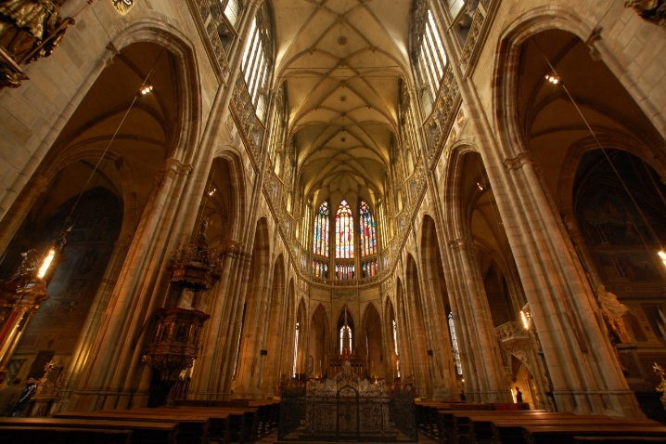  St. Vitus Cathedral in Prague, Czech Republic
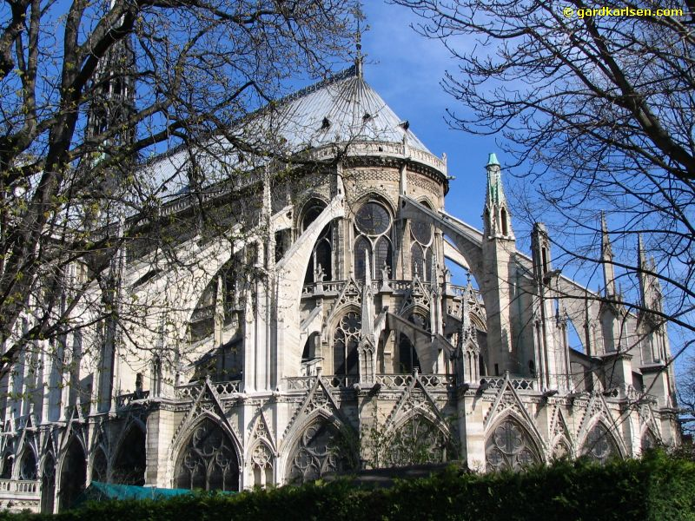
The Cathedral of Notre Dame

Cathédrale Notre Dame de Paris, or Our Lady of Paris Cathedral, is one of the most famous gothic cathedrals in Europe. Notre Dame is 420 ft. long, 226 ft. wide, and its two towers are 226 ft. high. Construction on the cathedral began in 1163 and was completed in 1345.

The gothic style of architecture was common in the late Middle Ages. Common features of gothic cathedrals included architectural innovations, including: large columns, high celings with ribbed vaults, flying buttresses, and large stained glass windows. Gothic cathedrals were usually the tallest and largest buildings in a city.
Marchione di Coppo Stefani, The Florentine Chronicle
Marchione di Coppo Stefani was born in Florence in 1336. He wrote his Florentine Chronicle in the late 1370s and early 1380s. Stefani, Marchione di Coppo. Cronaca fiorentina. Rerum Italicarum Scriptores, Vol. 30. , ed. Niccolo Rodolico. Citta di Castello: 1903-13.

…It was such a frightful thing that when it got into a house, as was said, no one remained. Frightened people abandoned the house and fled to another. Those in town fled to villages. Physicians could not be found because they had died like the others. And those who could be found wanted vast sums in hand before they entered the house. And when they did enter, they checked the pulse with face turned away. They inspected the urine from a distance and with something odoriferous under their nose. Child abandoned the father, husband the wife, wife the husband, one brother the other, one sister the other. In all the city there was nothing to do but to carry the dead to a burial. And those who died had neither confessor nor other sacraments. And many died with no one looking after them. And many died of hunger because when someone took to bed sick, another in the house, terrified, said to him: "I'm going for the doctor." Calmly walking out the door, the other left and did not return again…

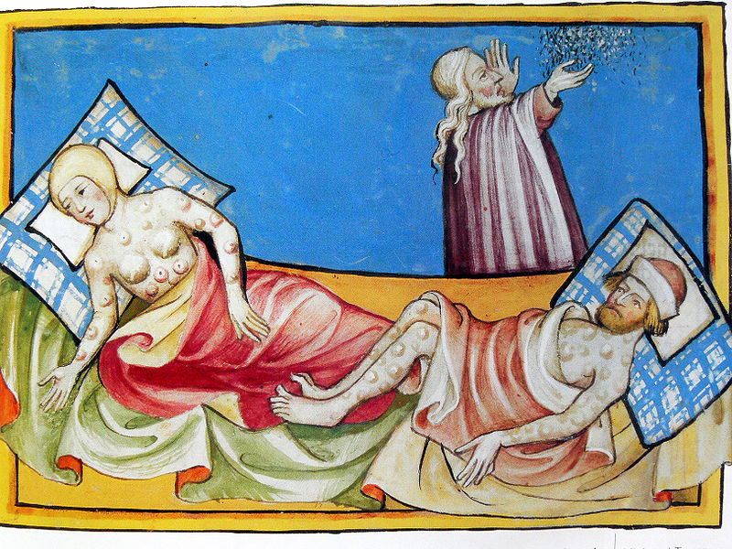
Illustration of the Black Death from the Toggenburg Bible (1411)

