News Media
Objective:
- What does it mean to assess the news?
- Why can’t we just trust what we read/hear?
- Why is it important to know how to access the news?

What is the difference between NEWS vs. ENTERTAINMENT?
Truth vs Rating
One medium is meant to provide truths and the other is for ratings however, sometimes the line between news and entertainment is blurred. Then it becomes the viewers job to figure where the line between truth and entertainment starts and ends.

Misrepresentation
- If it sounds too good to be true… it probably isn’t. Misrepresentation is when facts taken out of context and presented as complete truths.
- Misrepresentation is often used to sensationalize something – get an emotional reaction out of the view. This could be a positive or negative emotion.
- Sensationalist claims hidden behind credible language, such as
  - “A new study shows…​”
  - “Experts are saying…”​

Media Bias
Feel or show inclination or prejudice for or against someone or something. ​Generally, leans either right or left (Conservative or Liberal)

“Fake News”
- No a new concept​
  - Comes from the term - “Yellow Journalism” (late-19th century) ​
- Journalism that is based on exaggerated or sensations

Examples of Media Bias
Omission – leaving one side out of an article or a series of articles over a period of time
Selection of Sources – including more sources that support one view over another
Story Selection – a pattern of highlighting news stories that support one side of an issue over another
Placement – the location in the paper or article where a story or event is printed; a pattern of placing news stories so as to downplay information supportive of one side
Labeling – comes in two forms: ​
- Tagging of person from one party or group with extreme labels while leaving the other side unlabeled or with more mild labels.​
A reporter not only fails to identify a liberal or conservative as such, but also describes the person or group with positive labels, such as “an expert” or “independent consumer group”​
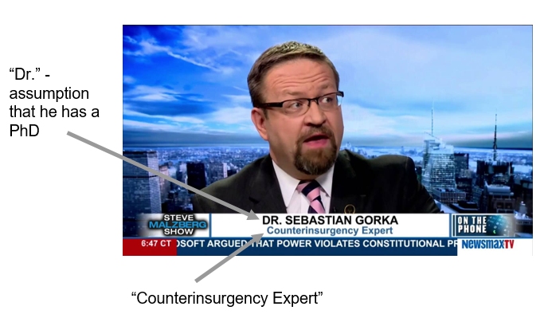
Spin – occurs when the story has only one interpretation of an event or policy, to the exclusion of the other. Spin involves tone- a reporter’s subjective comments about objective facts
Ignoring Facts
- Tend to be extremists
- Goal is discredit the other side using any means
- Appeal to emotion
Stories usually include statements that are factually incorrect and can be easily disproved

Credible News Sources | Off Limits Sources
- Politico.com  - Associated Press  - New York Times  - USA Today  - BBC  - Reuters  - NPR  - Wall Street Journal | - Infowars  - Daily Kos  - Blaze  - Breitbart  - Huffington Post  - Salon  - Anything that reports more celebrity news than current events (Buzzfeed)
Heavily Biased:
- MSNBC
- Fox News

