Direction: Read the examples below and then fill out the following table. While reading, focus your attention on similarities and differences between the examples.

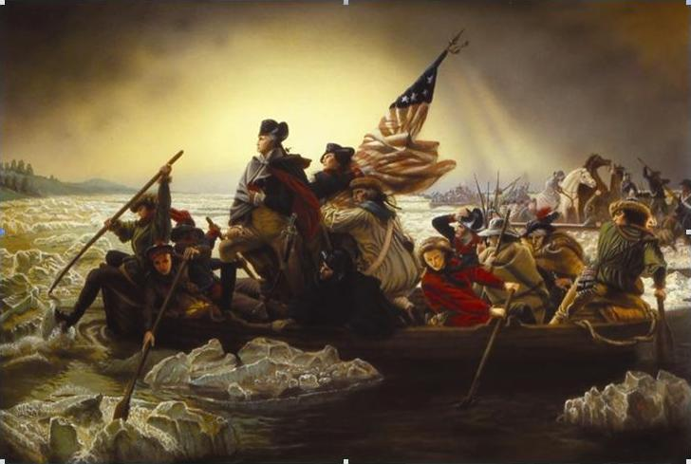
Example 1: A political uprising during the last of the 18th century, in which thirteen colonies in North America joined together to break free from the British Empire. They, the colonists, first rejected the authority of the Parliament of Great Britain to govern them from overseas without representation, and then expelled all royal officials. The colonists wanted more say in how they were governed Skirmishes between British troops and colonial militiamen in Lexington and Concord in April 1775 kicked off the armed conflict, and by the following summer, the rebels or colonists were waging a full-scale war for their independence. Major battles occurred until 1781 when British and American negotiators in Paris signed preliminary peace term in Paris. The fighting officially stopped when Great Britain formally recognized the independence of the United States in the Treaty of Paris on September 3, 1783.

Vocabulary:
Parliament: branch of government that makes laws, similar to Congress
skirmishes: a fight with small bodies of troops
militiamen: member of a militia, soldier independence: being able to self-rule

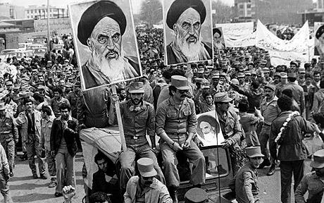
Example 2: Prior to this example, Iran was ruled by Shah Reza Pahlavi. The Shah (emperor) gave most of the power to his close relations and friends. During the 1970s the gap between Iran’s rich and poor grew. Distrust of the Shah’s economic policy and resentment of his autocratic style fueled dissent against his regime. Promising social and economic reform, Ayatollah Khomeini prescribed a return to traditional religious values, which many Iranians liked. In the late 1970s, a series of large-scale, increasingly violent anti-Shah protest swept Iran. The Shah left Iran for exile in mid-January of 1979, and the resulting power vacuum was filled two weeks later when Ayatollah Khomeini returned to Tehran to greetings by several million Iranians. The royal regime collapsed shortly after that. On February 11, guerrillas and rebel troops took armed street fighting and overwhelmed any troops still loyal to the Shah. Iran voted, by national referendum, to become an Islamic Republic on April 1st, 1979, and later approved a new theocratic constitution whereby Khomeini became the Supreme Leader of the country in December, 1979.

Vocabulary:
Resentment: being bitter autocratic: having absolute power dissent: disagreement
regime: a government national referendum: when everyone votes directly
theocratic: a government where religion and politics are one

Example 3: The nation of Panem's seat of power is a city called, the Capitol. Citizens of the Capitol are generally preoccupied with extravagant fashion, parties, and mass entertainment. Most Capitol citizens are either oblivious of, or totally unconcerned with, the poverty and desperation that prevails outside of the Capitol. The areas outside of the Capitol is divided into twelve districts under the totalitarian dictatorship, headed by the tyrannical President Coriolanus Snow. A thirteenth district had existed but was destroyed by the Capitol about 75 years ago, during a national rebellion called the Dark Days.
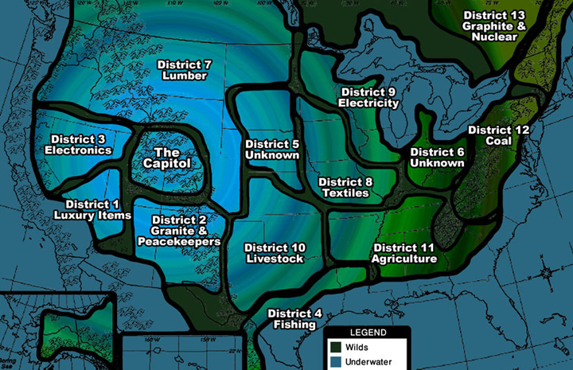
After the events of the Dark Days, the Treaty of Treason was put in effect, stating that each district outside of the Capitol has to put forth one male and one female between the ages of 12 and 18 each year as tribute to the Capitol. These tribute victims are then forced to fight to the death until only one remains at an events called, “The Hunger Games”. This “game” serves as a means to punish the citizens of Panem for their rebellion 75 years ago and to remind them of the consequences of further rebellion.
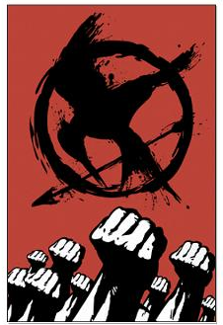
75 years after the first rebellion, a second rebellion began when rebels across the country backed by District 13 rose up in an armed conflict against the Capitol’s military forces (Peacekeepers). The rebellion itself began to gain momentum during the 74th Hunger Games when District 12’s tributes, Katniss Everdeen and Peeta Mellark threatened to commit a double suicide. This caused the Gamemaker Seneca Crane to let them both win. President Snow felt that this was a sign that the Districts could overcome the powers of the Capitol.

The first known rebellious activity took place in District 8 after the Victory Tour for the 74th Hunger Games concluded. After the train left District 8, a violent riot erupted. Rioters seized control of several strategic positions throughout the district, all the while engaging in an active fight with large contingents of Peacekeepers. Although the rebels initially had the upper hand due to the surprise assault, they were unorganized and ill-equipped to engage in sustained fighting between themselves and the better trained and equipped Peacekeeper forces. Capitol hovercrafts gave air support to the Peacekeepers, bombing rebel positions as the Peacekeepers advanced. Eventually, the Peacekeepers quelled the rebellion and set the entire district under martial law. However, fighting continued and ultimately every district began to side with the rebels, except for District 2. The Capitol would eventually fall, President Snow would be killed and Alma Coin, leader of the rebels would become the new president, only to be executed by the war hero Katniss Everdeen in retaliation for killing her sister.

Vocabulary:
extravagant: expensive ill-equipped: under supplied contingents: group of troops or police
dictatorship: government by a dictator with absolute power
tyrannical: exercising power in a cruel and oppressive way
rebellion: an act of violent or open resistance to a government or ruler
Gamemaker: designer of the Hunger Games
hovercrafts: a vehicle that is capable of travelling over land, water, mud and ice by a cushion of air
quelled: to put an end to martial law: where normal law is suspended and there is a military government

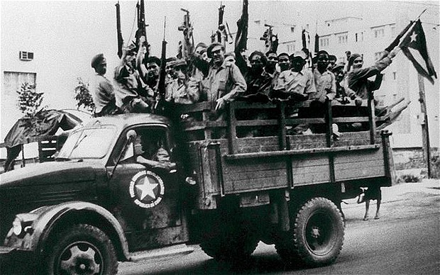
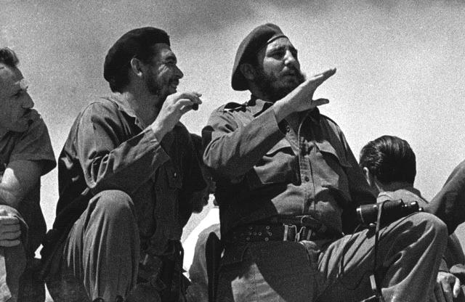
Example 4: On March 10th 1952, General Batista overthrew the president of Cuba, Carlos Prio Socarras, and canceled all elections. This angered a young lawyer, Fidel Castro, and for the next seven years he led attempts to overthrow Batista’s government. On July 26th, 1953, Castro led an attack against the military barracks in Santiago, but he was defeated and arrested. Although Castro was sentence to 15 years in prison, Batista released him in 1955 in a show of supreme power. Castro did not back down and gathered a new group of rebels in Mexico. On December 2nd, 1956, he was again defeated by Batista’s army and fled to the Sierra Maestra (mountain range). He began using guerrilla tactics to fight Batista’s armed forces, and, with the aid of other rebellions throughout Cuba, he forced Batista to resign and flee the country on January 1st, 1959. Castro became the prime minister of Cuba in February and had about 550 of Batista’s associates executed. In the immediate aftermath of the revolution, Castro’s government began a program of nationalization and political consolidation that transformed Cuba’s economy and civil society.

Vocabulary:
military barracks: place where soldiers live
guerrilla tactics: a form of warfare where small groups of combatants use military tactics such as ambush, sabotage, raids, hit and run, etc. etc.
prime minister: the head of an elected government
program of nationalization: where business and natural resources in a country gets owned by the government
political consolidation: uniting politically
civil society: community of citizens linked by common interest and activity

Direction: After reading the four examples, fill out the graphic organizer below with your group.
 | Identify the group fighting | Who wins? | What do the winners do? | What changes happened? | Was there any violence?
Example 1
Example 2
Example 3
Example 4

