10th Grade Integrated Source Evaluation Assignment- Semester 1

Objective: To develop source analysis skills and reflect on your research project.
Assignment: Your task is to examine the sources (including your poem) that you used in your research paper and evaluate the values and limitations of those sources. Your will create an annotated bibliography and presented your source analysis in some form of visual display of your choosing.

Step 1: Source Selection
For this source evaluation assignment, you will only need to analyze 4 sources – 3 of researched sources and your poem from your research paper. If you used more sources in your research paper, you are awesome for being above and beyond! You will not need to analyze all of your source, just 4!
Step 2: Create an Annotated Bibliography
You can find step by step detail of how to create an annotated bibliography at Ms. Bacon’s website: http://msbacon.com/documents/AnnotatedBibliography.pdf
The four basic required components of your annotated bibliography are:
- Citation (MLA)
- Summary
  - What are the main arguments?
  - What is the point of this book or article?
  - What topics are covered?
  - If someone asked what this article/book is about what would you say?
- Evaluation
  - Write an OPCVL sources analysis paragraph discussing the sources: origin, purpose, content, values, and limitation (consider the language used in the text).
- Reflection
  - Was this source helpful to you?
  - How does it help you shape your argument?
  - How can you use this source in your research project?
  - Has it changed how you think about your topic?
Step 3: Presentation
- Create a visual representation of your annotated bibliography that is presentable and includes the following:
- Your research paper’s title
- Your research question
- Your poem
- if you have a short poem, you must have the entire poem on your poster
- if your poem is really long, please pull excerpts of the poem, relevant to your paper
- The summary, evaluation and reflection for all 4 sources
- Submit your annotated bibliography to Turnitin.com.
- Presentation
  - Explain how your sources helped you answer your research question (write your papers)
  - Challenges and difficulties you faced with the sources
  - What might you do different next time?
Example of how your poster could look like:
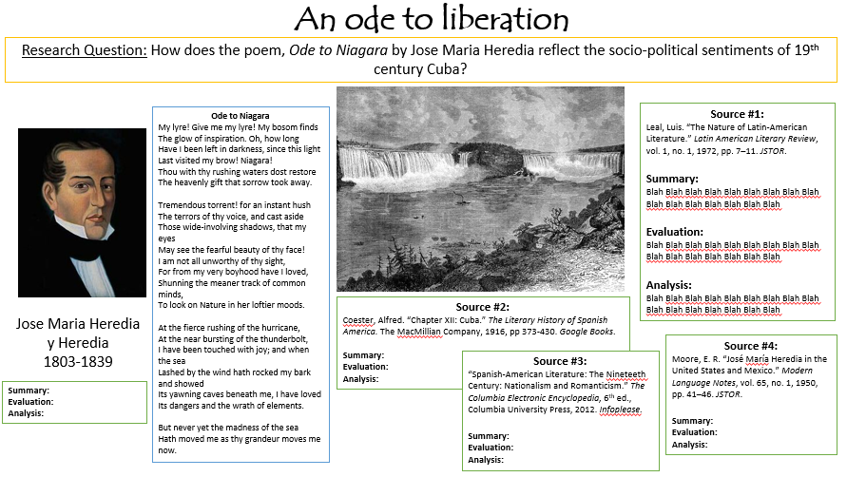

Integrated Source Evaluation Assignment Rubric
 | Exceeds Standard | Meets Standard | Approaches Standard | Does not meet standard | Missing
OPCVL  Evaluation | Analysis and evaluation of origins, purpose and content is detailed throughout all source analyses and accurate with explicit reference to the value and limitations. | Analysis and evaluation of origins, purpose and content is accurate, but value and limitations could be more detailed or are not consistently detailed throughout | Analysis and evaluation of sources is present, but reference to the value and limitations of origins, purpose and content is limited, superficial, or at times inaccurate | Attempts to analyze source, but lack evaluation of origin and/or purpose and/or content. | No clear source evaluation present or just lists content without any evaluation
Language & Formatting | Words convey meaning clearly & precisely; strong word choice  Accurate spelling, grammar, and punctuation  Perfect MLA Formatting | Words convey meaning clearly; adequate word choice  Inconsequential errors in spelling, grammar, and/or punctuation | Meaning at times unclear because of word choice; simplistic/informal word choice  Noticeable errors in spelling, grammar, and/or punctuation  Minor errors in formatting | Word choice impedes readability; word choice is weak  Sentences are awkward; many run-ons or fragments  Errors in spelling, grammar, and/or punctuation are distracting  Major errors in formatting | Is not formatted to MLA standards
Presentation | Visual is creative, neat, well organized and meets all requirements.  Presentation is clear, articulate, well-prepared and meet requirements. | Visual is neat, well organized and meets all requirements.  Presentation is clear, prepared and meet requirements. | Visual is sloppy or information is cluttered.  Visual missing some required components.  Presentation is unprepared.  Presentation missing some required components. | Visual lacks major requirements.  Presentation is unprepared.  Presentation missing major requirements. | No visual.

