The Birth of Israel
The creation of Israel in 1948 complicated U.S. efforts to retain friends in the Persian Gulf. In the aftermath of the Holocaust, the Jewish quest for a homeland gained support in the United States. But most Arab leaders opposed Israel because the country was carved out of lands where Arabs already lived. Saudi King Saud Ibn Saud even threatened to break his contract with ARAMCO to protest U.S. policy. Nonetheless, the United States played a key role in bringing the Jewish state into existence. The story of Israel’s creation starts in the late 1800s.
What was Zionism?
“Zion” is a Hebrew word for the land of Israel. Zionism, the movement for establishing the state of Israel, had its origins in Europe, where Jews had long been subjected to persecution. At the end of the nineteenth century, some Jewish intellectuals argued that their people could flourish safely only by establishing an independent state. They looked in East Africa and South America before settling on Palestine, a significant region in Jewish history, as the best choice. In the early 1900s, these Zionists started buying land there for Jewish settlements.
“One fundamental fact—that we must have Palestine if we are not going to be exterminated.”
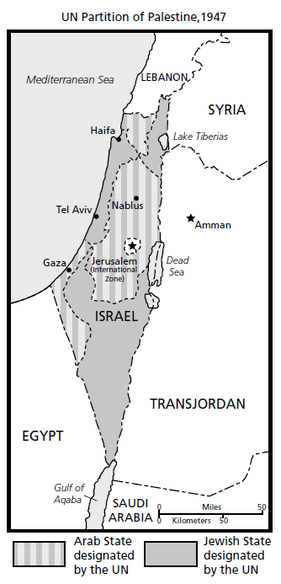
—Chaim Weizmann, Zionist leader, 1919

What promises did Great Britain make to Arabs and Jews during World War I?
In 1917, Britain issued the Balfour Declaration, pledging to help establish “a national home” for Jews in Palestine. The British hoped that the declaration would rally Jewish opinion, especially in the United States, behind the Allied war effort in World War I. At the same time, the British promised Sharif Hussein, the ruler of Mecca, that they would help to set up an independent Arab state across all of the Arab areas of the Ottoman Empire after the war. In exchange, Hussein began a rebellion against the Ottomans in Arabia, which helped the Allies win the war. These dual promises proved to have long-term effects on the Middle East.
Between 1922 and 1939, as Zionists moved to Palestine, the Jewish population in Palestine rose from 84,000 to 445,000, or about 30 percent of the total population. But the Zionist movement increasingly found itself at odds with the aspirations of Palestinian Arabs seeking to forge a state of their own. British efforts to strike a balance between Palestinians and Jews failed to hold down the escalating tensions.
Why did many Jews head to Palestine in the 1940s?
Zionism might not have fulfilled its mission without the tragedy of the Holocaust. During World War II, Adolf Hitler sought to exterminate all of the Jews of Europe. Six million Jews were put to death by the Nazis.
After the war, hundreds of thousands of Jewish refugees saw immigration to Palestine as the only hope for rebuilding their lives. The Holocaust also won the Zionists widespread sympathy in the West. President Truman (1945-1953) became personally committed to the Zionist cause.
In 1947, the British announced they would leave Palestine within a year, turning over responsibility for the mandate to the newly formed United Nations (UN). A plan to partition the mandate between Jews and Palestinian Arabs passed the UN General Assembly by two votes, thanks in large part to U.S. lobbying.
How did Israel’s creation plant the seeds of conflict?
The Zionists viewed the UN partition plan as their best hope for a Jewish state, and accepted it. The Arab world did not, fearing that Arabs, who were in the majority, would become subject to a minority immigrant population. Arabs also felt that the creation of Israel would led to instability in the region.
Knowing the British would pull their troops out the day the partition went into effect, Zionists began to take control of the territory allotted to them by the UN, including many predominantly Arab towns that had been included in the Jewish zone. As the date of the British departure approached, violence erupted as each side fought to extend its control. Fighting soon engulfed much of Palestine. This violence was intense; there were terrorist acts on both sides.
With the withdrawal of the last British forces in May 1948, Israel proclaimed itself a state and immediately won recognition from the United States and the Soviet Union. The Arab states refused to recognize Israel.
For some time, Palestinian Arabs had been supported in their fight by men and arms from neighboring Arab countries. The day after Israel declared itself an independent state, forces from Egypt, Syria, Transjordan (now known as Jordan), Lebanon, and Iraq invaded Israel.
“It does not matter how many [Jews] there are. We will sweep them into the sea.”
—Abd al-Rahman Azzam Pasha, Secretary General of the Arab League, 1948
Fearing just such an attack, Zionist leaders had been collecting weapons for years. By the time a truce was reached in January 1949, the Zionists had seized a large portion of the land that the UN had designated for the Palestinians. What was left of the former mandate was claimed by Transjordan (which absorbed the West Bank) and Egypt (which held the Gaza Strip). More than 750,000 Palestinians became refugees. Arab countries refused to make peace with or to recognize the fledgling Israeli state. Without a treaty, the cease-fire lines in effect became the borders between Israel and its neighbors. The animosity set the stage for decades of conflict.
Although the Truman administration approved a $100 million loan for Israel, U.S. policy remained torn. Within the State Department (the governmental body responsible for carrying out U.S. foreign policy), many officials advised against supporting Israel. They feared an Arab backlash against the United States. These fears were based in part on the United States’ need for oil from Arab nations, and also on the growing presence of the Soviet Union following World War II.

