Source: Poop Happened!: A History of the World from the Bottom Up - May 11, 2010 by Sarah Albee
The Black Death: Pestilence and Poop
In 1348, Bubonic plague – known as the black death- swept through Europe, the near east and North Africa, having already decimated the populations of India, China and East Asia. Within two years, it would kill one-third of the population of Europe and probably that many in the Near East and North Africa as well.
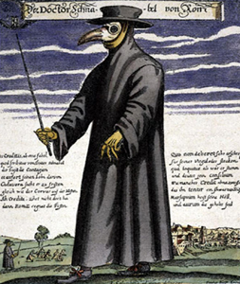
Victims developed large black swellings (buboes) in their necks, groins, or armpits, and often a black rash spread over much of their body. This when you are bitten by a diseased flea. An oozy, pus-filled blister appears and the site of the flea bite. The nearest lymph nodes start to swell, harden and turn black, eventually forming lemon sized buboes. The spit, vomit and excrement of a plague victim smelled so horrible that sick people became objects of revulsion rather than pity. Doctors who managed not to die of the disease walked around wearing beaky masks in an attempt to ward off infection.
Painting of a Dark Age Doctors. They would wear masks filled with popery and good smells. They believed that disease was spread through smell
“The symptoms were not the same as in the East, where a gush of blood from the nose was the plain sign of inevitable death; but it began both in men and women with certain swellings in the groin or under the armpit. They grew to the size of a small apple or an egg, more or less, and were vulgarly called tumors. In a short space of time these tumors spread from the two parts all over the body. Soon after this the symptoms changed and black or purple spots appeared on the arms or thighs or any other part of the body, sometimes a few large ones, sometimes many little ones.” - Giovanni Boccaccio, The Decameron describing the symptoms of the plague
Although no one knew it at the time, the disease was spread by flea bites. Germ carrying fleas lived on black rats. The rats fed on the garbage and excrement in the streets. When they died, the infected flea hopped onto a human instead. When it bit the human, the bacillus (disease causing bacteria) entered the person’s blood stream. Since most medieval cities were overcrowded and filthy, the rat population thrived, and the plague spread.
Fleas on small rodents (rats, mice, gerbils) would spread the disease

Disease in Superstitious Times
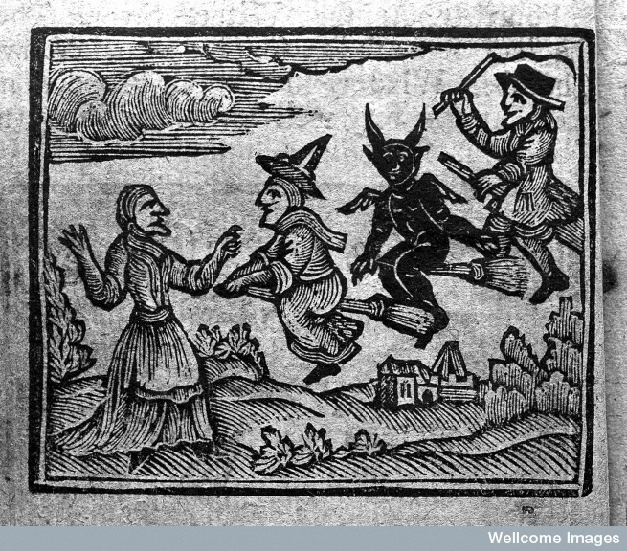
In the Middle Ages, the link between filthiness and disease was far more obvious. People still hadn’t figured out that living so close to their own waste could cause terrible epidemics. Instead, most people believed that disease was caused by demons or God’s wrath to their own sin. It was a time when perfectly rational people believed in ogres, dragons, witches, and trolls. One widely accepted explanation for the Black Death epidemic in the 1300s Paris was that it was an astrological problem: Saturn wan in the same sky as Jupiter! Such superstitious beliefs may strike is as absurd or odd, but what were people supposed to think when a person would wake up healthy in the morning and be dead by lunchtime? Because people lacked knowledge of the true source of disease, they would believe an evil curse was as good an explanation as any. It would be hundreds of years before people started to understand that their vermin-infested clothing and the piles of filth that contaminated their water were major reasons behind the spread of disease. It is no wonder that most common treatment for most serious diseases was prayer.
People during the Dark Ages were very fearful of witches, demons and bad spirits. They believed that bad events and tragedies were caused by them.
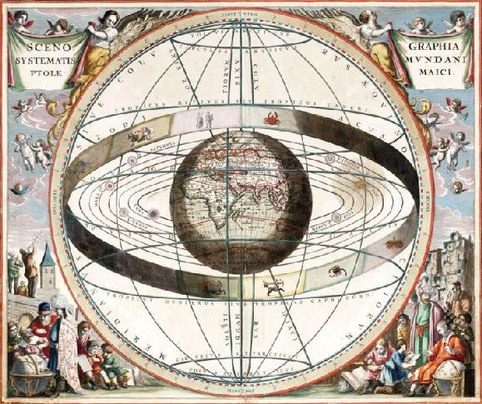
The plague was most commonly seen as God’s punishment. Biblically, plague has always been seen as a means of divine punishment by God. The classic example of this is the Ten Plagues brought against the Egyptians when Pharaoh refuses to release God’s people, Israel. The Bible does not prophesy the Black Death, so it is difficult to characterize it as a scourge from God. It is sufficient if the plague provoked men to think of their priorities and their own mortality to the extent that they might seek God. People beat themselves with whips to show that they repented their sins and would be known as flagellants. The movement became popular after the disillusionment with the Church’s reaction to the Black Death. Normal life broke down as people fled cities or hid in their homes to avoid contracting the plague from neighbors and relatives.
Fear and ignorance led people to blame the disease on groups who were already hated. In Spain, the Muslims were blamed, in France, the English. But Jewish people more than any other group, were singled out. Because Jews were less susceptible to the Black Death than their neighbors (likely the result of Jewish ritual regarding personal hygiene), Jews were accused of poisoning the wells. In one Swiss town, every Jew was rounded up and burned to death (below). Hundreds of other massacres of Jews took place in Europe during the plague.
Astronomy was a very important part of belief and superstition during the Dark ages.
The influence of the Church was greatly diminished during this period. Many became disillusioned with the Church for its inability to halt the relentless progression of the disease. Faith in God was sorely tested. . . ”Why did God not answer and turn the disease back?” Many monasteries suffered high mortality due to the fact that disease victims sought help from the clergy, thus passing the disease to them. As a result, the dead clergy were replaced overtime with new church leaders – but these lacked the experience and dedication of those who had passed on. Persecutions against “minority groups” Jews, foreigners in general, and lepers arose; they were blamed for having “caused” the plague.

Use your notes to summarize what you read in this section:

____________________________________________________________________________________________________________________________________________________________________________________ ____________________________________________________________________________________________________________________________________________________________________________________
____________________________________________________________________________________________________________________________________________________________________________________
____________________________________________________________________________________________________________________________________________________________________________________
____________________________________________________________________________________________________________________________________________________________________________________
____________________________________________________________________________________________________________________________________________________________________________________
__________________________________________________________________________________________
____________________________________________________________________________________________________________________________________________________________________________________
__________________________________________________________________________________________
__________________________________________________________________________________________

