The Dividing of a Continent: Africa's Separatist Problem

By Max Fisher
Europe's arbitrary post-colonial borders left Africans bunched into countries that don't represent their heritage, a contradiction that still troubles them today.
South Sudanese officials look at the newly unveiled map of Sudan after separation. (Reuters)
When the nations of Nigeria and Cameroon went to settle a border dispute in 2002, in which both countries claimed an oil-rich peninsula about the size of El Paso, they didn't cite ancient cultural claims to the land, nor the preferences of its inhabitants, nor even their own national interests. Rather, in taking their case to the International Court of Justice, they cited a pile of century-old European paperwork.

Cameroon was once a German colony and Nigeria had been ruled by the British empire; in 1913, the two European powers had negotiated the border between these West African colonies. Cameroon argued that this agreement put the peninsula within their borders. Nigeria said the same. Cameroon's yellowed maps were apparently more persuasive; it won the case, and will officially absorb the Bekassi Peninsula into its borders next month.

The case, as Reuters once explained, "again highlighted Africa's commitment to colonial borders drawn without consideration for those actually living there." African borders, in this thinking, are whatever Europeans happened to have marked down during the 19th and 20th centuries, which is a surprising way to do things given how little these outsider-drawn borders have to do with actual Africans.

In much of the world, national borders have shifted over time to reflect ethnic, linguistic, and sometimes religious divisions. Spain's borders generally enclose the Spanish-speakers of Europe; Slovenia and Croatia roughly encompass ethnic Slovenes and Croats. Thailand is exactly what its name suggests. Africa is different, its nations largely defined not by its peoples heritage but by the follies of European colonialism. But as the continent becomes more democratic and Africans assert desires for national self-determination, the African insistence on maintaining colonial-era borders is facing more popular challenges, further exposing the contradiction engineered into African society half a century ago.
When European colonialism collapsed in the years after World War Two and Africans resumed control of their own continent, sub-Saharan leaders agreed to respect the colonial borders. Not because those borders made any sense -- they are widely considered the arbitrary creations of colonial happenstance and European agreements -- but because "new rulers in Africa made the decision to keep the borders drawn by former colonizers to avoid disruptive conflict amongst themselves," as a Harvard paper on these "artificial states" put it.

Conflict has decreased in Africa since the turbulent 1960s and '70s, and though the continent still has some deeply troubled hotspots, the broader trend in Africa is one of peace, democracy, and growth. The threats of destabilizing war, of coups and counter-coups, have eased since the first independent African leaders pledged to uphold European-drawn borders. But a contradiction remains in the African system: leaders are committed to maintaining consistent borders, and yet as those governments become more democratic, they have to confront the fact that popular will might conflict.
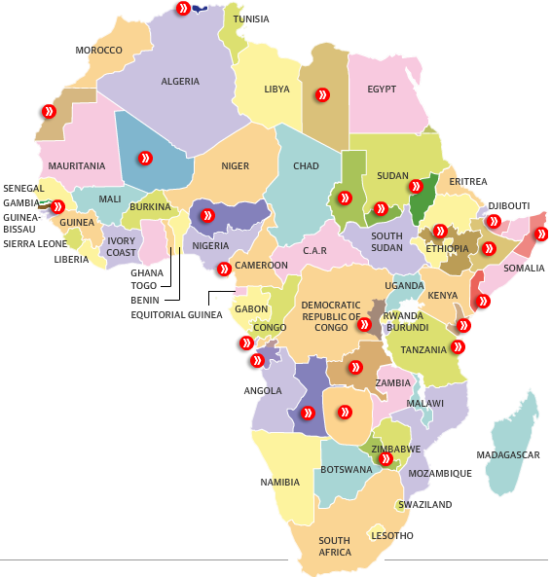
The Guardian
A Kenyan group called the Mombasa Republican Council is just the latest of Africa's now 20-plus separatist movements, according to the Guardian, which has charted them all in an interactive map. The Mombasa group wants the country's coastal region to secede, citing its distinct heritage due to centuries of trade across the Indian Ocean. It's unlikely to happen, but as the Guardian notes it's part of a trend of "encouraged" separatist movements as Africans seem to become more willing and interested in pursuing borders that more closely reflect the continent's diverse ethnic, religious, and linguistic lines.

Consider Angola. In 1575, 100 Portuguese families and 400 Portuguese troops landed on the African continent's southwestern coast at what is now the city of Luanda. They expanded from there, stopping only when they reached German, Belgian, or British claims. The Portuguese consolidated the vast, California-sized holdings into a single colony. The only thing that the people who lived there shared in common was that they answered to Portuguese masters, and in 1961 that they rebelled against that rule, which they threw off in 1975. They became the country of Angola, an essentially invented nation meant to represent disparate and ancient cultures as if they had simply materialized out of thin air that very moment. Today, as some Angolans are quick to point out, their country is composed of ten major ethnic groups, who do not necessarily have a history of or an interest in shared nationhood. This may help explain why there are two secessionist groups in Angola today.

Had pre-industrial-era Portuguese colonists not pressed so far up along Africa's western coast so quickly, for example, then Africa's seven million Kikongo-speakers might today have their own country. Instead, they are split among three different countries, including Angola, as minorities. The Bundu dia Kongo separatist group, which operates across the region, wants to establish a country that would more closely resemble the old, pre-colonial Kongo Kingdom, and give the Kikongo-speakers a country.

There's no reason to think that Bundia dia Kongo or the Mombasa Republican Council have any chance at establishing sovereign states; their movements are too weak and the states they challenge are too strong. But, as the 2011 division of Sudan into two countries demonstrated, the world can sometimes find some flexibility in the unofficial rule about maintaining colonial African borders. Sudan was an extreme example, an infamously poorly demarcated state that encompassed some of the widest ethnic and religious gulfs in the world, but as G. Pascal Zachary wrote in TheAtlantic.com at the time, it provided an opportunity to question whether those arbitrary borders hold Africa back. After all, in countries such as Nigeria or the Democratic Republic of Congo, disparate cultural groups have tended to band together, competing with one another for finite power and resources, sometimes disastrously. With tribal identities strong and national identities weak (after all, the latter tends to be ancient and deeply rooted, the latter new and artificial), national cooperation can be tough.

Of course, the actual practice of secession and division would be difficult, if it's even functionally possible; Africa's ethnic groups are many, and they don't tend to fall along the cleanest possible lines. The debate over whether or not secession is good for Africa, as Zachary explained, is a complicated and sometimes contentious one. But the simple fact of this debate is a reminder of Africa's unique post-colonial borders, a devil's bargain sacrificing the democratic fundamental of national self-determination for the practical pursuits of peace and independence. And it's another indication of the many ways that colonialism's complicated legacy is still with us, still shaping today's world.
This article available online at:
http://www.theatlantic.com/international/archive/2012/09/the-dividing-of-a-continent-africas-separatist-problem/262171/
Copyright © 2013 by The Atlantic Monthly Group. All Rights Reserved.

