The Historical Origins of Africa’s Underdevelopment
Nathan Nunn 08 December 2007

Slavery, according to historical accounts, played an important role in Africa’s underdevelopment. It fostered ethnic fractionalisation and undermined effective states. The largest numbers of slaves were taken from areas that were the most underdeveloped politically at the end of the 19th century and are the most ethnically fragmented today. Recent research suggests that without the slave trades, 72% of Africa’s income gap with the rest of the world would not exist today.

Africa’s poor economic performance is one of the largest puzzles in growth and development economics. A large literature has emerged trying to explain the source of Africa’s growth tragedy. See for example Easterly and Levine (1997), or Sachs and Warner (1997).
African historians have documented the detrimental effects that the slave trades had on the institutions and structures of African societies. Historical evidence from case studies show how the slave trade caused political instability, weakened states, promoted political and social fragmentation, and resulted in a deterioration of domestic legal institutions.
Between 1400 and 1900, the African continent experienced four simultaneous slave trades. The largest and most well-known is the trans-Atlantic slave trade where, beginning in the fifteenth century, slaves were shipped from West Africa, West Central Africa, and Eastern Africa to the European colonies in the New World. The three other slave trades -- the trans-Saharan, Red Sea, and Indian Ocean slave trades -- are much older and predate the trans-Atlantic slave trade. During the trans-Saharan slave trade, slaves were taken from south of the Saharan desert and shipped to Northern Africa. In the Red Sea slave trade, slaves were taken from inland of the Red Sea and shipped to the Middle East and India. In the Indian Ocean slave trade, slaves were taken from Eastern Africa and shipped either to the Middle East, India or to plantation islands in the Indian Ocean.
In a recent paper, I explore empirically whether these detrimental effects of the slave trades can explain part of Africa's current underdevelopment.¹ I do this by first constructing estimates of the number of slaves taken from each country in Africa between 1400 and 1900. The estimates are constructed by combining data of the number of slaves shipped from each African port or region with data from historical documents reporting the ethnic identities of slaves taken from Africa.
If the slave trades are partly responsible for Africa's current underdevelopment, then looking across countries within Africa, one should observe that the parts of Africa that are the poorest today are also the areas from which the largest number of slaves were taken in the past. My research shows that this is indeed the case. The countries from which the most slaves were taken (taking into account differences in country size) are today the poorest in Africa. This can be seen in figure 1, which shows the relationship between the number of slaves taken between 1400 and 1900 and average real per capita GDP measured in 2000. As the figure clearly shows, the relationship is extremely strong. As well, the relationship remains robust when many other key determinants of economic development are taken into account.
An alternative explanation for the relationship is that the parts of Africa from which the largest number of slaves were taken were initially the most underdeveloped. Today, because these characteristics persist, these parts of Africa continue to be underdeveloped and poor. My research examines this alternative hypothesis by testing whether it was in fact the initially least developed parts of Africa that engaged most heavily in the slave trades. I find that the data and the historical evidence suggest that, if anything, it was the parts of Africa that were initially the most developed, not least developed, that supplied the largest number of slaves.
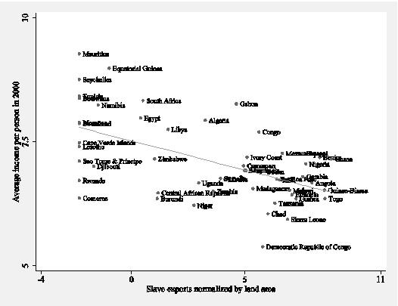
Figure 1
I also use instrumental variables to identify the causal effect of the slave trade on economic development. As instruments, I use distances from each country to the locations of the demand for slaves as instruments to estimate the causal effect of the slave trades on economic development. The instrumental variables estimates confirmed the OLS estimates, suggesting that increased extraction during the slave trades resulted in worse economic performance.
Although much research remains to be done before we have a clear and deep understanding of exactly how and why the slave trades have been so detrimental for economic development, my initial analysis of the data is consistent with historic accounts suggesting that the slave trades impeded the formation of broader ethnic groups, leading to ethnic fractionalisation, and that the slave trades resulted in a weakening and underdevelopment of political structures. The countries from which the largest numbers of slaves were taken are also the areas that had the most underdeveloped political structures at the end of the 19th century, and they are also the areas that are the most ethnically fragmented today.
Using the estimates of the impact of the slave trades on economic development, I am able to provide an estimate of how much more developed Africa would be if the slave trades had not taken place.
The average per capita income level of the countries in Africa is $1,834, measured in 2000. This is significantly lower than the income for the rest of the world (which is $8,809), and it is even much lower than the income of other developing countries (which is $4,868).²

Conclusions
According to my calculations, if the slave trades had not occurred, then 72% of the average income gap between Africa and the rest of the world would not exist today, and 99% of the income gap between Africa and the rest of the underdeveloped world would not exist. In terms of economic development, Africa would not look any different from the other developing countries in the world.
This finding is striking. These results may not be the final and definitive explanation for the origins of Africa’s severe underdevelopment, but they do provide very strong evidence that much of Africa’s poor performance can be explained by its history, which is characterised by over 400 years of slave raiding.

References
William Easterly and Ross Levine, “Africa’s Growth Tragedy: Policies and Ethnic Divisions,” Quarterly Journal of Economics, 112 (1997): 1203–1250.
Jeffrey Sachs and Andrew Warner, “Sources of Slow Growth in African Economies,” Journal of African Economies, 6 (1997): 335–376.

Footnotes
1 Nunn, Nathan. “The Long-Term Effects of Africa’s Slave Trades.” Quarterly Journal of Economics, 123 (2008): forthcoming.
2 I define a developing country as one with 2000 per capita income less than $14,000. According to this definition the poorest developed country is Portugal, and richest developing country is Barbados.

