8Name: ________________________________
The Troubles
1968 – 1998
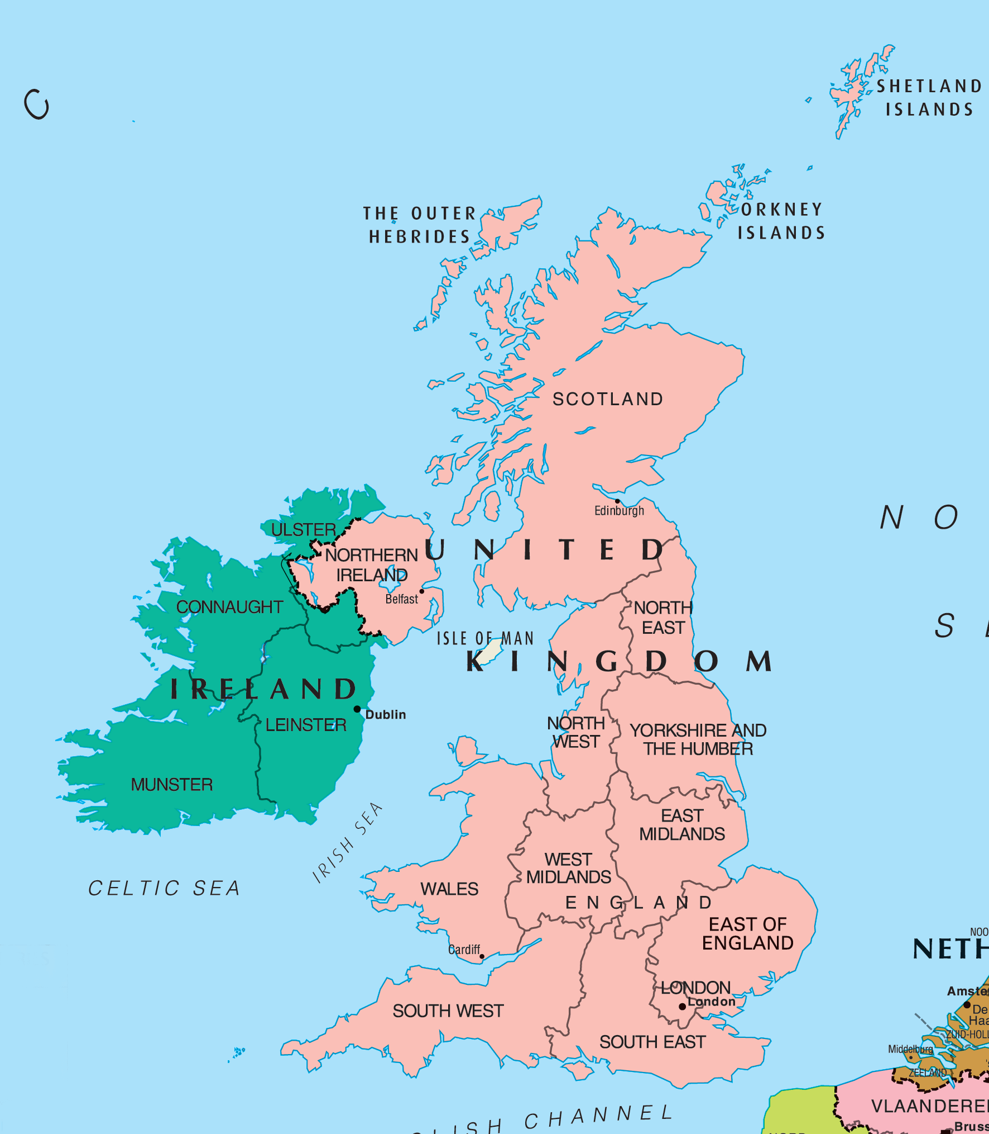
*Context:
The island of Ireland has had a long and tumultuous relationship with its neighbor to the east, Britain for hundreds of years. Falling under completed British control from the time of King Henry VIII in 1536, Ireland became a domain of Britain for hundreds of years.
The Irish, a predominately Catholic population experienced extreme discrimination and oppression by their predominately Protestant English rulers. To establish a stronger hold in Ireland and further suppress Catholic dissents, the English began to send English and Scottish Protestants to settle in Ireland to diffuse Protestantism on the Island. This was successful in the Northern regions of Ireland, where a large number of Irish intermarried and mixed with Protestants. Thus the majority of Northern Ireland is Protestant to this day and feel a cultural affinity to Britain. However, there is still a Catholic minority in the region. Those who were Protestant were favored over Catholics and thus had more political power.
Despite this, the island still remain largely and fervently Catholic and continued to push for fair treatment and even for some, independence. The push for Irish independent became even more apparent with the rise of nationalism and national self-determinism in the 19th century. The Irish successfully gained complete independence from Britain in 1937. However Northern Ireland choose to remained with Britain after independence, and still to this day.
What has been the relationship between Ireland and Britain historically?

What is the religious makeup of Ireland?

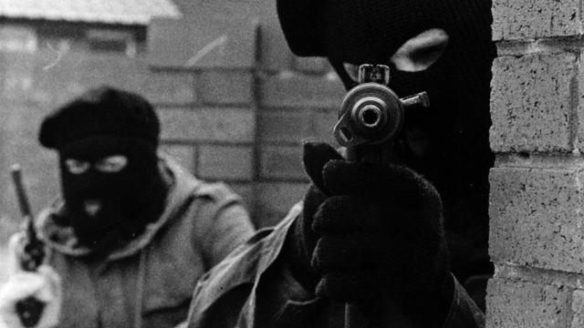
The Troubles refers to a violent thirty-year conflict framed by a civil rights march in Londonderry on 5 October 1968 and the Good Friday Agreement on 10 April 1998. At the heart of the conflict lay the constitutional status of Northern Ireland.
The goal of the unionist and overwhelmingly Protestant majority was to remain part of the United Kingdom. The goal of the nationalist and republican, almost exclusively Catholic, minority was to become part of the Republic of Ireland.
This was a territorial conflict, not a religious one. At its heart lay two mutually exclusive visions of national identity and national belonging. The principal difference between 1968 and 1998 is that the people and organizations pursuing these rival futures eventually resolved to do so through peaceful and democratic means. This ascendancy of politics over violence was not easily achieved.
During the Troubles, the scale of the killings perpetrated by all sides - republican and loyalist paramilitaries and the security forces - eventually exceeded 3,600. As many as 50,000 people were physically maimed or injured, with countless others psychologically damaged by the conflict, a legacy that continues to shape the post-1998 period.
What was the Troubles? (Summarize the conflict)

Who were the unionist?

Who were the nationalist/republican?

Direct rule returns
In 1968, the Northern Ireland parliament had been dominated by unionists for over fifty years. Its attempts to solve social and political ills, such as institutional discrimination against Catholics, were too slow for nationalists and republicans and too quick for many unionists. This gave rise to growing tension and violence between the two communities.
The mounting scale of the disorder led successive UK governments to intervene. In 1969, the situation was so grave that British troops were sent to help restore order. By 1972, things had deteriorated so badly that the British government suspended the Northern Ireland parliament and imposed direct rule from London.
Relegated to the margins of UK politics for half a century, Northern Ireland had suddenly reclaimed center stage.
What was the reason behind the growing tension and violence between unionist and nationalist/republicans?

How did the British government deal with the tension and violence in Northern Ireland?
Sunningdale's frosty reception
Direct rule by British ministers was viewed as a short-term measure and a process designed to restore self-government to Northern Ireland was soon underway. The first major attempt was the 1973 Sunningdale Agreement, which provided for both a devolved, power-sharing administration and a role for the Irish government in the internal affairs of Northern Ireland - the so-called 'Irish dimension'.
Together with the UK and Irish governments, just three Northern Ireland political parties participated in the Sunningdale talks - the Ulster Unionist Party (UUP), the nationalist Social Democratic and Labour Party (SDLP) and the centre-ground Alliance Party. The Democratic Unionist Party (DUP) was wholly opposed to Sunningdale and did not participate. Representatives of the 'extremes' on both sides - loyalist and republican paramilitaries - were not invited.
Sunningdale's political institutions collapsed in early 1974, toppled by the Ulster Workers Council (UWC) strike, a near-insurrection spearheaded by a coalition of unionists and loyalists that effectively brought Northern Ireland to a standstill.
Although Sunningdale was ultimately a failure, it contained the seeds of the much more intricate and successful Good Friday Agreement twenty five years later.
What was the Sunningdale Agreement?

Why did the Sunningdale Agreement fail?

The Anglo-Irish Agreement
As the cycle of violence escalated post-Sunningdale, further efforts were made by successive UK governments to devise a political settlement, but only one acceptable to those parties it considered "legitimate" and non-violent.
The Anglo-Irish Agreement (AIA) in 1985 was a serious attempt to achieve a political accord that resolved the "Irish question". It gave the Irish government an advisory role in the affairs of Northern Ireland and determined there would be no change in Northern Ireland's constitutional status - no Irish unification in other words - without the consent of its people. Nonetheless, the treaty broadly alienated the unionist community, which opposed Irish involvement and rejected the proposal for a devolved, power-sharing government. Among the major parties in Northern Ireland, only the SDLP and Alliance Party supported the AIA.
Sinn Féin, the "political wing" of the IRA, was as vociferously opposed to the agreement as unionists. The party had grown in prominence and influence since republican hunger striker Bobby Sands was elected a member of parliament on a wave of popular support shortly before he died in 1981. It had shown Sinn Féin the power of political engagement and led to the adoption of a strategy known as "the armalite and the ballot box" in which the IRA would continue the "armed struggle" while Sinn Féin contested Northern Ireland elections.
Crucially, when the IRA announced a ceasefire in 1994, mainstream republican leaders had recognized that the 'long war' was unwinnable. (Equally, the British Army had come to the view that the conflict could not be won solely by military means.) Sinn Féin’s commitment to politics and the electoral process enabled it to enter negotiations designed to end the Troubles and restore self-government to Northern Ireland.
What was the Anglo-Irish Agreement (AIA)?

Was the AIA successful? What did it lead to?

Peace process
Cross-party talks began in earnest in 1996. In almost all quarters, a combination of political realism and war-weariness cleared the path to negotiation. Importantly, President of the United States Bill Clinton took an active personal role, appointing veteran US senator George Mitchell as chair of the talks process that concluded in the Good Friday Agreement.
Negotiating with Sinn Féin was unpalatable for many unionists and loyalists. The UUP, under leader David Trimble, agreed to participate only if those they regarded as terrorists were committed to exclusively peaceful and democratic means. Representatives of loyalist paramilitaries also agreed to take part. By contrast, Ian Paisley's Democratic Unionist Party (DUP) viewed the whole process as unacceptable. They abandoned the talks and opposed the subsequent agreement, but still took their seats in the Northern Ireland Assembly that resulted.
Nevertheless, the Good Friday Agreement marked a seismic shift in Northern Ireland's political landscape. The UUP and SDLP agreed to accept power-sharing, including with former paramilitaries who were committed to the peace process.
All signatories to the agreement endorsed the "consent principle". This meant that any change in Northern Ireland's constitutional status - Irish unification - would happen only when the popular majorities voted in favour in separate referendums held at the same time on both sides of the border.
What was the Good Friday Agreement?

What are the conditions for Irish unification (Northern Ireland uniting with the Republic of Ireland)?

After the Good Friday Agreement
If the Good Friday Agreement and the return of self-government to Northern Ireland (but still a part of the UK) had been an enormous challenge for all concerned, so was its fitful implementation. Many significant issues remained unresolved in 1998, not least the decommissioning of republican and loyalist weapons.
These and other matters were now susceptible to the force of argument rather than the argument of force. Even so, the first phase of devolved power-sharing was to prove fragile and short-lived, requiring the re-introduction of direct rule from 2002 until 2007.
Only then had sufficient trust been developed between the communities to enable the restoration of devolution.
When government returned to Stormont buildings in Belfast, this time it involved a fully inclusive power-sharing arrangement that embraced both the DUP and Sinn Féin - now the dominant parties within their respective electorates.
This partnership of constitutional opposites is perhaps the most remarkable outcome of the Troubles, and one that underlines the triumph of politics over violence in post-conflict Northern Ireland.
What issues remained unsolved after the Good Friday Agreement?

What are some positive things that came as a result of the Good Friday Agreement?

How is the Troubles a contradiction of the ideas expressed during the Cold War that Western democracy and capitalism will lead to peace and stability?

